

VistA Blood Establishment Computer Software (VBECS) Version 2.2.1

Technical Manual-Security Guide

June 2017

Department of Veterans Affairs

Enterprise Project Management Office

This page intentionally left blank.

# Revision History

| **Date** | **Revision** | **Description** | **Author** |
| --- | --- | --- | --- |
| 4/25/17 | 1.0 | Modified VistA Blood Establishment Computer Software (VBECS) 2.2.0 Technical Manual-Security Guide, Version 3.0 to create the VistA Blood Establishment Computer Software (VBECS) 2.2.1 Technical Manual-Security Guide, Version 1.0:   * Global: Replaced "2.2.0" with "2.2.1”. * Global: Replaced “August 2016” with “April 2017”. * Configure Interfaces section: Globally updated Interface screenshots and steps to reflect current GUI design. * Configure Divisions section, Assumptions: Revised 4th entry. * Configure Divisions section, Additional Information: Revised last entry. * Defect 459220 * Log into VBECS Administrator section: Revised entire section. * Defect 387860 * Globally changed National Service Desk to Service Desk (SD). * Log into VBECS Administrator, Step 4: Added note about certificates seen during sign on process. * Configure Broker Parameters: Added this new section. * Defect 481735 * Maintenance Operations section, Limitations and Restrictions: Added that eXM must be disabled. * Configure Divisions section, Limitations and Restrictions: Added that eXM must be disabled. * Defect 310050 * Report Share section: Added. * Configure the Report Share section: Revised Step 10. Added Step 11. * Defect 461544 * Applying Windows Updates section: * Revised second paragraph. * Revised Tables 6 and 7. | BBM Team |
| 6/6/17 | 2.0 | Modified VistA Blood Establishment Computer Software (VBECS) 2.2.1 Technical Manual-Security Guide, Version 1.0 to create the VistA Blood Establishment Computer Software (VBECS) 2.2.1 Technical Manual-Security Guide, Version 2.0:   * Global: Replaced “April 2017” with “June 2017”. * Defect 510537 * Configure Broker Parameters section: Added new Figure 64 and revised Step 4 to see the new Figure 64 for instructions on obtaining a valid VistA Broker IP/Port. Revised first sentence under VBECS Administrator column to say ‘four-octet’ instead of ‘standard version 4 or version 6”. | BBM Team |

This page intentionally left blank.

Table of Contents

Revision History 3

Introduction 1

VBECS Version Numbers 1

Related Manuals and Reference Materials 3

How This Technical Manual-Security Guide Is Organized 5

Terms 5

Figures and Tables 5

Screen Shots 5

Commonly Used System Rules 5

Enterprise Operations Tasks 5

Appendices 5

Remote Desktop Configuration (Windows 7) 7

Server Name and Screen Resolution 7

Sound 10

Keyboard 11

Connection Speed 12

Save Settings 13

Create a Remote Desktop Connection Shortcut for VBECS 14

Server Hardware and System Configuration 15

Required Peripherals 17

Printers 17

Report Printer 17

Label Printer (Zebra ZM400, Z4Mplus and ZT410) 23

Scanners 24

Workstation Configuration 26

Report Share 26

Implementation and Maintenance (Enterprise Operations Only) 27

Periodic System Maintenance 27

SQL Maintenance Jobs 28

SQL Maintenance Job Alerts 29

SQL Database Backups 30

Applying Windows Updates 30

Applying Updates to VBECS SQL Server System 33

ePolicy and Virus Definitions 44

VistA Maintenance Operations 45

Set Up VBECS Outbound Logical Links 45

Set Up the VBECS Inbound Logical Link 47

Start VistA HL7 Logical Links 48

Monitor VBECS HL7 Logical Links 48

Configure VBECS VistALink Links 50

VBECS Maintenance Operations 51

Configure Interfaces 57

Configure Divisions 73

Configure Users 81

Record Workload Data 87

External Interfaces 89

VistALink Remote Procedure Calls 89

VBECS Windows Services 90

Troubleshooting 93

Remote Desktop Session Issues 93

Remote Desktop Services Licensing Issues 94

Stopping and Starting VBECS Services 96

VBECS Auditing 97

VBECS Exception Logging 97

VBECS Application Interfaces 97

Zebra Printer Problems 106

Scanner Problems 108

Archiving and Recovery (Enterprise Operations Only) 113

Restore the Databases 113

Failover 115

Performance 117

Locking 117

Security 119

Access Request Process 119

Active Directory 119

Group Policy 119

System Center Operations Manager 119

Application-Wide Exceptions 120

Health Product Support Access 121

Configuring the App Server and Lab Workstations 123

Server Tasks (Enterprise Operations Only) 123

Grant User Permissions 123

Configure the Report Share 125

Workstation Tasks 130

Update the RDP Shortcut 130

Configure a Shortcut to the Report Share 132

Glossary 135

Appendices 137

Appendix A: Instructions for Capturing Screen Shots 137

Appendix B: Data Center Instructions (Enterprise Operations only) 139

Purpose 139

Server Configuration 139

Initial Setup Tasks 140

Ongoing Tasks 142

Appendix C: Auditing on VBECS Servers 143

Index 145

This page intentionally left blank.

# Introduction

The main purpose of the VistA Blood Establishment Computer Software (VBECS) is to automate the daily processing of blood inventory and patient transfusions in a hospital transfusion service.

 Unauthorized access or misuse of this system and/or its data is a federal crime. Use of all data, printed or electronic, must be in accordance with VA policy on security and privacy.

 Do not change the system!The U.S. Food and Drug Administration classifies this software as a medical device. Unauthorized modifications will render this device an adulterated medical device under Section 501 of the Medical Device Amendments to the Federal Food, Drug, and Cosmetic Act. Acquiring and implementing this software through the Freedom of Information Act require the implementer to assume total responsibility for the software and become a registered manufacturer of a medical device, subject to FDA regulations. Adding to or updating VBECS software without permission is prohibited.

## VBECS Version Numbers

In previous VBECS patch releases, the user documentation referred to the VBECS version in a 4-digit format (e.g., 2.1.0.2 – where 2.1.0 represents the patch version and the last digit (2) is the patch build number).

The VBECS version (Figure 1) is now represented with only the first three digits (e.g., 2.1.0) and appears that way in all user documentation to simplify readability

The revision letter tracks database-only updates (e.g., blood product table updates, canned comments updates). The revision letter is normally a single alpha character (e.g., C), but can be two characters (e.g., AA, AB, AC) in the unlikely event that more than 25 database updates are made before a code change is implemented. The revision letter starts at A with each new code change and is incremented to B when the first database-only update is made. The revision letter is then updated by one character in the alphabet for every successive database-only update until a new code change is implemented, at which time the revision letter reverts back to A. The version submitted for system testing is revision A, but the version customers receive can be revision A, B or a higher revision letter.

Figure 1: Example of Help, About VBECS

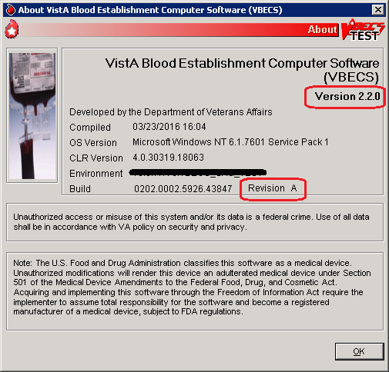

DR 4992

The VBECS Administrator and VBECS applications, when started, will verify that the application code (binary build number) matches the SQL Server code (database build number) in order to ensure that application servers and SQL servers are patched and remain in sync with each other. In the rare event that they fall out of sync, the applications will present the following error message (Figure 2) and close until both the code and the database are in sync.

Figure 2: Example of System Error

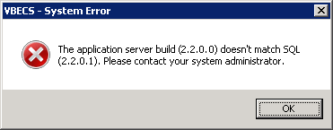

## Related Manuals and Reference Materials

[*HL7 V2.3.1 Implementation Guide*](http://www.hl7.org/implement/standards/product_brief.cfm?product_id=141#ImpGuides)

*CPRS-VBECS Interface (OR*3.0*212) Release Notes April 2009*

*PIMS V. 5.3 Technical Manual*

*Duplicate Record Merge: Patient Merge Technical Manual Version 7.3 April 1998 Revised December 2010*

*Kernel Systems Manual Version 8.0, Chapter 1: Sign-On Security/User Interface, pp. 13–20*

[*Manage Open Sessions and Files in Windows 2008 R2*](http://technet.microsoft.com/en-us/library/cc725689.aspx)

*Health Product Support Release of Products and Patches Guide V2.3 Updated: February 2014*

*VistA Blood Establishment Computer Software (VBECS) 2.2.1 User Guide*

*VistA Blood Establishment Computer Software (VBECS) 2.2.0 Automated Instrument and Instrument Manager for <instrument> Setup Guide*

*VistALink Version 1.5 Developer-System Manager Manual*, Chapter 6: Security Management, pp. 34–35

[*Windows Server 2008R2 Security Guide*, Microsoft Corporation](http://technet.microsoft.com/en-us/library/gg236605.aspx)

This page intentionally left blank.

# How This Technical Manual-Security Guide Is Organized

Outlined text is used throughout this guide to highlight warnings, limitations, and cautions:

 Warnings, limitations, cautions

### Terms

For consistency and space considerations, the pronouns “he,” “him,” and “his” are used as pronouns of indeterminate gender equally applicable to males and females.

In many instances, a user may scan a barcode or enter data manually (by typing). The term “enter” is used throughout this guide to mean “enter manually.”

See the Glossary for definitions of other terms and acronyms used in this guide.

### Figures and Tables

If you refer to figures and tables from the Technical Manual-Security Guide in your local policy and procedure documents, you may wish to use their titles only, without figure or table numbers: as the technical manual-security guide is updated, those numbers may change.

### Screen Shots

Because VBECS is a medical device, screen shots must be captured at various points throughout the technical manual-security guide to meet FDA requirements for objective evidence and documentation. A (camera) at the beginning of each step that requires a screen capture will identify these points. For more information, see Appendix A: Instructions for Capturing Screen Shots.

### Commonly Used System Rules

This section includes system rules that apply to several or all options.

MBR_1.09 Only one instance of the VBECS Administrator can run at a time.

BR_12.02 VBECS captures changes to verified data for inclusion in the Audit Trail Report.

VBECS protects application data through encapsulation. Encapsulation promotes data security by hiding the implementation details.

### Enterprise Operations Tasks

Some of the tasks in this guide are executed by members of Enterprise Operations (EO) affiliated with the data center where VBECS Servers are hosted. These tasks are differentiated by the text in the headings with (Enterprise Operations Only) noted in the heading.

### Appendices

The appendices contain reference materials.

While pressing the Ctrl button, left-click on a section name or page number in the table of contents to move to that section or page. The index does not incorporate this feature.

.

# Remote Desktop Configuration (Windows 7)

Configure the screen resolution, sound, and connection speed, and create a Remote Desktop Connection shortcut on each VBECS workstation.

## Server Name and Screen Resolution

To set the screen resolution:

1. Double-click  (the **Remote Desktop Connection** icon).
2. Click **Show Options** (Figure 3).

Figure 3: Example of Remote Desktop Connection Options

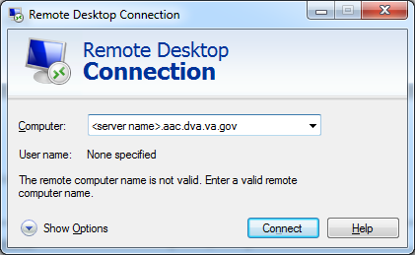

1. Click the **General** tab(Figure 4).
2. Enter the VBECS application server’s fully qualified domain name (FQDN) in the **Computer** field. The name will always be your server name followed by **aac.dva.va.gov**

Figure 4: Example of General Tab Computer and Domain

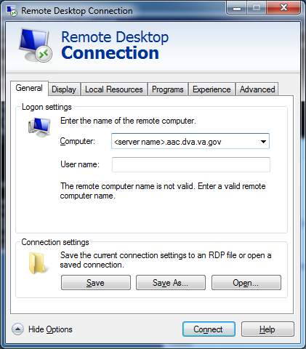

1. Click the **Display** tab (Figure 5).
2. Click, hold, and slide the pointer to a screen resolution of **Full Screen**.

Figure 5: Example of Display Tab

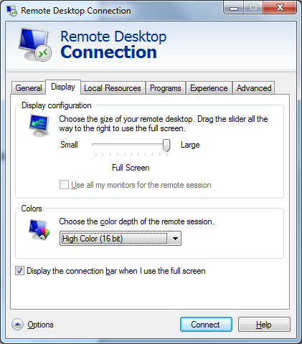

## Sound

To enable sound:

1. Click the **Local Resources** tab (Figure 6).
2. Click the **Settings** button.

 Failure to properly configure the sound disables audible alerts throughout VBECS.

Figure 6: Example of Remote Computer Sound

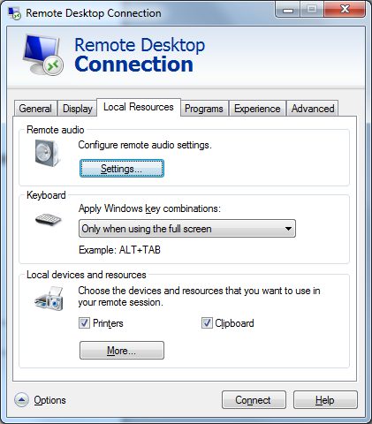

1. Select **Play on this computer** (Figure 7) from the Remote audio playback section.
2. Click the **OK** button.

Figure 7: Remote audio playback selection

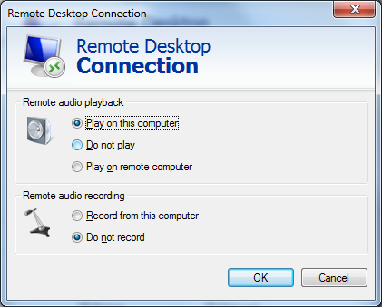

## Keyboard

To configure keyboard settings:

1. Click the **Local Resources** tab (Figure 8).
2. Select **On this computer** from the Keyboard drop-down list.

Figure 8: Example of Remote Computer Keyboard

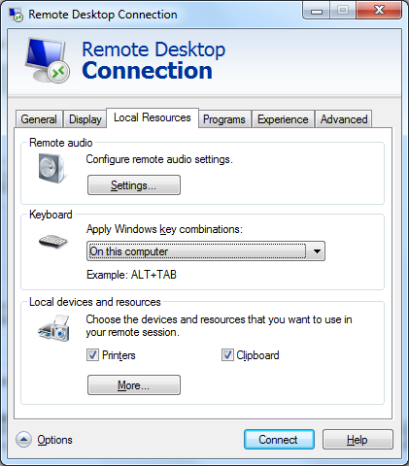

## Connection Speed

To set the connection speed:

1. Click the **Experience** tab (Figure 9).
2. Select **LAN (10 Mbps or higher)** from the **Choose your connection speed to optimize performance** drop-down list. Deselect **Font smoothing**.

Figure 9: Example of Connection Speed

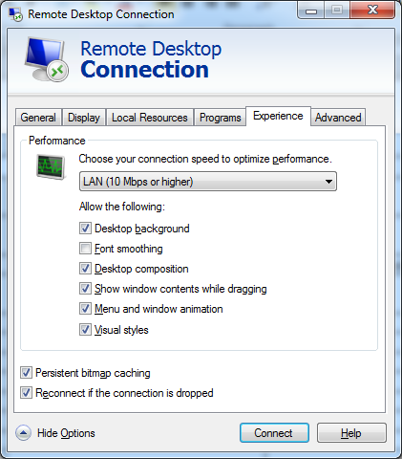

## Save Settings

To save the settings:

1. Click the **General** tab (Figure 10).
2. Click **Save As**.

Figure 10: Example of General Tab Save As



## Create a Remote Desktop Connection Shortcut for VBECS

1. To create a Remote Desktop Connection shortcut for VBECS (Figure 11), save the file as VBECS.rdp in the **C:\Users\Public\Public Desktop** folder.

Figure 11: Example of Remote Desktop Connection Shortcut for VBECS

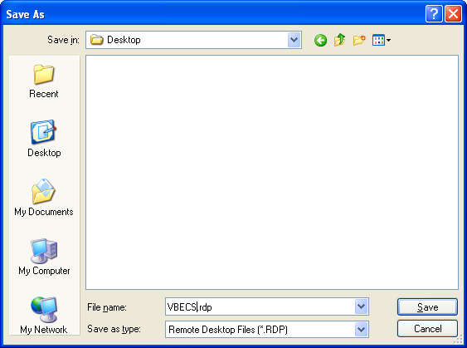

Double-click the shortcut to launch the Remote Desktop Connection to VBECS.

The Windows start-up sound confirms that the sound functions.

# Server Hardware and System Configuration

The VBECS application requires hardware and system software to service the requirements of a user population of five users in a standard configuration and up to twenty-five users in an integrated Veterans Integrated Service Network (VISN) environment.

VBECS 2.0.0 is installed in a virtualized environment using vSphere® 5.5 as the virtualization platform. This section focuses on the configuration of the virtual machines. Table 15 and Table 16 contain the virtual machine specifications for the Application and SQL Servers respectively. The System Schematic diagram (Figure 12) describes the major system components:

* **Application Server (App Server)**: This is a Windows 2008 Server Enterprise Edition R2 (x64) server and is the execution environment for the VBECS application (both Test and Production). It also functions as a Remote Desktop Protocol (RDP) Server. Each VBECS instance (single or multidivisional) has a unique App Server.

The App Server also communicates with and exchanges information with VistA applications and other HL7 interfaces through messages formatted using Extensible Markup Language (XML) and Health Level 7 (HL7) over Transmission Control Protocol/Internet Protocol (TCP/IP) networking.

* **SQL Server**:This is a Windows 2008 Server Enterprise Edition R2 (x64) server that runs SQL Server 2012. It hosts the VBECS’ databases for each single or multidivisional instance. Up to 15 sites share a single SQL Server.

SQL Servers exist in an AlwaysOn cluster, which consists of three nodes. The Primary and High Availability servers reside at the primary site while a Disaster Recovery server resides at an alternate location:

* + Primary SQL Server: This server fields all requests. Its data are replicated to the High Availability and Disaster Recovery servers.
  + High Availability (HA) SQL Server: This server provides database backup services through synchronous replication. Its data are guaranteed to be consistent with the Primary. It becomes the Primary should the original Primary server fail or become unreachable. Failover to this server is automatic.
  + Disaster Recovery (DR) SQL Server: This server resides at a remote site and provides database backup services through asynchronous replication. It becomes the Primary server should both the Primary and HA server fail or become unreachable. Failover to this server is a manual process.
* **Windows 7 Workstations**: Users continue to access the VBECS application using Remote Desktop Services.

Figure 12: System Schematic



## 

## Required Peripherals

Table 1 describes additional required hardware.

Table 1: Additional Required Hardware

|  |  |
| --- | --- |
| **Additional Required Hardware** | |
| Barcode Scanner | Hand-Held Model 4600 (This is the model distributed with the original VBECS deployment and is now discontinued. The successor is the Honeywell Xenon 1900.) |
| Report Printer | HP LaserJet 9040dn (sites may elect to use a different report printer) |
| Label Printer | Zebra ZM400, Z4MPlus or ZT410; Must print at 300 DPI and have Ethernet connectivity. |

## Printers

### Report Printer

A laser printer capable of printing 8.5" x 11" sheets may be used. VBECS supports duplex printing, but not all printers are duplex capable. Consult the printer documentation to determine if it has this capability.

#### Installing a Printer (Server Administrators Only)

To install a printer, execute the following instructions:

1. Copy the printer driver to the **C:\temp** directory on the app server.
2. Log into the app server with administrative privileges.
3. Click **Start**, **Devices and Printers.** The Device and Printers window is displayed (Figure 13). Click the **Add a printer** button**.**

Figure 13: Example of Devices and Printers, Add a printer

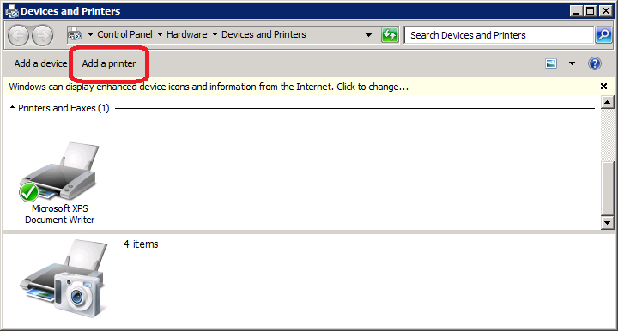

1. In the Add Printer Wizard screen, select the **Add a local printer** button (Figure 14).

Figure 14: Example of Add Printer Wizard



1. On the Choose a printer port window, select **Create a new port** radio button. From the Type of port: drop-down, select **Standard TCP/IP Port**. Click **Next** (Figure 15).

Figure 15: Example of Add Printer Wizard



1. Enter the IP address of the printer in the **Hostname or IP address** field (the **Port Name** field will populate automatically). Click **Next** (Figure 16).

Figure 16: Example of TCP/IP Settings

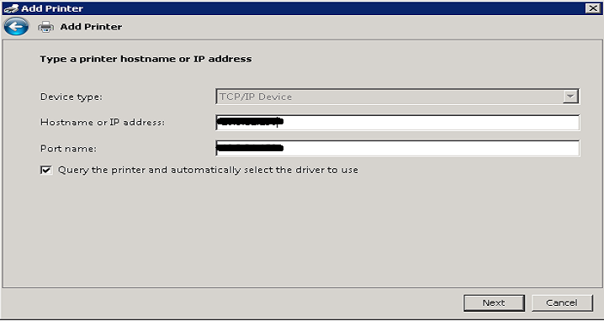

1. Click **Finish** (Figure 17).

Figure 17: Example of Review Settings

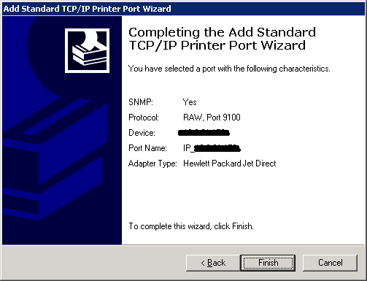

1. To select a driver, click **Have Disk** (Figure 18).

Figure 18: Example of Add Printer Wizard



1. Click **Browse** (Figure 19). Navigate to the driver that you copied to **C:\temp\** in Step 1. Click **Open** (Figure 20).

Figure 19: Example of Install From Disk



Figure 20: Example of Select Driver



1. Click **OK** (Figure 19).
2. For a single-division site, enter **VBECS Printer** as the printer name. For a multidivisional site, enter **VBECS Printer** and the site name (e.g., VBECS Printer Hines). Click **Next** (Figure 21)

Figure 21: Example of Add Printer Wizard



1. Click the **Do not share this printer** radio button. Click **Next** (Figure 22).

Figure 22: Example of Add Printer Wizard



1. Click **Next** (Figure 23).

Figure 23: Example of Add Printer Wizard



### Label Printer (Zebra ZM400, Z4Mplus and ZT410)

 Do not install the label printer on the VBECS Server. Connectivity is configured in VBECS Administrator.

VBECS is configured to work only with Zebra printers: VBECS uses Zebra Programming Language to communicate with the printer. Other requirements:

* Ethernet connectivity: the label printer must have an Ethernet card
* Must print on 4" x 4" label stock
* Must print at 300DPI

Prior to configuring the label printer, load the ribbon and label stock and ensure that the printer is on. If the printer does not display PRINTER READY, there is a problem that must be resolved before proceeding. Refer to the Zebra user guide or printer CD for more information. All guides may be found on the [VBECS SharePoint](http://vaww.oed.portal.va.gov/projects/vbecs/Pages/HardwareManuals.aspx).

## Scanners

Scanners used with VBECS must be able to scan Codabar, ISBT 128, and PDF-417 barcodes. To configure a scanner:

1. Connect the scanner to the workstation.
   1. To configure a **Hand-Held 4600** scanner, scan the barcode in Figure 24.

Figure 24: Configuration barcode for a Hand-Held 4600



* 1. To configure a **Honeywell Xenon 1900** scanner, scan the barcodes in Figure 25 and Figure 26 sequentially.

Figure 25: Xenon 1900: Restore defaults



Figure 26: Xenon 1900: VBECS settings



To test the scanner, open Notepad. Print and scan the barcodes in Figure 27, Figure 28 and Figure 29. The Codabar and ISBT barcodes must scan as “~123456789”; the PDF 417 must scan as “~Testing.”

Save and print the Notepad file for validation records.

Figure 27: Codabar



Figure 28: ISBT 128



Figure 29: PDF 417



## Workstation Configuration

Specifications are as follows:

* Memory: 2GB
* Display: 17”
* Video: video card with 16-bit color and 1024 x 768 resolution
* Operating System: Microsoft Windows 7 Enterprise
* Input Devices: U.S. 101-key keyboard, mouse
* Audio: Sound card and speakers
* Personal Identity Verification (PIV) card reader: required for PIV card access

## 

## Report Share

# The VBECS system provides a share for users to access reports from their workstations (Configure a Shortcut to the Report Share). While VBECS administrators have the ability to create and delete files and folders, users have read-only access to the share.Implementation and Maintenance (Enterprise Operations Only)

 The U.S. Food and Drug Administration classifies this software as a medical device. Unauthorized modifications will render this device an adulterated medical device under Section 501 of the Medical Device Amendments to the Federal Food, Drug, and Cosmetic Act. Acquiring and implementing this software through the Freedom of Information Act require the implementer to assume total responsibility for the software and become a registered manufacturer of a medical device, subject to FDA regulations.

## Periodic System Maintenance

 The VBECS SQL Maintenance jobs run nightly from 10:00 PM to 1:00 AM (CST). Do not reboot the server during this time interval. Doing so may cause consistency and allocation errors.

The system will fail to function as intended when maintenance checks are not performed or are not performed correctly (Table 2).

Table 2: Periodic System Maintenance

| **Action** | **Frequency** | **Description** |
| --- | --- | --- |
| System Center Operations Manager (SCOM) Alerts | Daily | SCOM emails alert messages to a Server Administrators mail group. Investigate all alerts to completion. |
| Review Database Integrity Reports | Daily | Take action only upon receipt of a job failure email. See the SQL Maintenance Jobs section for more details. |
| Apply Windows Updates | Wednesday, two weeks after 2nd Tuesday of the month | See Applying Windows Updates. |
| VBECS Reports folder cleanupDR 4961 | Annually or as needed | Users are able to export reports to the D:\VBECSReports folder on the App Server. The D drive is 10 GB in size and logs are also stored there.  On an annual basis or whenever the folder is over 90% full, old reports must be deleted. This activity must be performed by a server administrator and should be coordinated with blood bank personnel. |

## SQL Maintenance Jobs

The VBECS databases are contained within Microsoft SQL Server and require regular maintenance jobs to backup, validate integrity, and improve performance. The jobs are automated and configured to run according to the specifications shown in Table 3, Table 4 and Table 5.

**System Level Jobs**: Each system level job executes against all databases found on the SQL system not contained in an Availability Group. Email alerts are sent to [*VAOITVBECSSQLSupport@va.gov*](mailto:VAOITVBECSSQLSupport@va.gov).

Table 3: System Level Jobs

| **Databases Affected** | **Job Name** | **Start Time** |
| --- | --- | --- |
| All databases not in an Availability Group | System_IntegrityCheck | 10:00pm |
| All databases not in an Availability Group (except TempDB) | System_FullBackups | 11:00pm |
| n/a | System_ResetServerLog | Every Saturday at 12:00am |

**Availability Group Level Jobs**: Each Availability Group level job executes against all VBECS databases found within the Availability Group indicated by the job name (Table 4). Email alerts are sent to the recipients defined in the targeted database’s CPRS interface (see SQL Maintenance Job Alerts section).

Table 4: Availability Group Level Jobs

| **Databases Affected** | **Job Name** | **Start Time** |
| --- | --- | --- |
| All VBECS databases in the Availability Group AGVISN*XX (XX is equal to the VISN number)* | AGVISN*XX*_DifferentialBackups | Every 6 hours between 3:00am and 10:00pm |
| AGVISN*XX*_TransactionalLogBackups | Every 2 hours between 2:00am and 11:00pm |
| AGVISN*XX*_ReIndexTables | 10:00pm |
| AGVISN*XX*_UpdateStats | 10:30pm |
| AGVISN*XX*_IntegrityCheck | 11:30pm |
| AGVISN*XX*_FullBackups | 12:15am |

**VBECS Level Jobs**: Each VBECS level job targets a single VBECS database indicated in the job name (Table 5). These jobs affect user data by expiring Component and Test Orders and marking units Presumed Transfused. Email alerts are sent to the recipients defined in the targeted database’s CPRS interface (see SQL Maintenance Job Alerts section).

Table 5: VBECS Level Jobs

|  |  |  |
| --- | --- | --- |
| **Databases Affected** | **Job Name** | **Start Time** |
| (Test SQL Server)  VBECS_*SSS*_TEST (SSS is equal to the Site Code) | AGVISN*XX*_VBECS_*SSS*_TEST_Background_Jobs | 12:01am |
| (Production SQL Server) VBECS_*SSS*_PROD | AGVISN*XX*_VBECS_*SSS*_PROD_Background_Jobs |

### SQL Maintenance Job Alerts

Email alert messages are sent only when a SQL maintenance job fails. System Level job alerts are sent to [*VAOITVBECSSQLSupport@va.gov*](mailto:VAOITVBECSSQLSupport@va.gov)and [*EOVBEDatabaseAdministration@va.gov*](mailto:EOVBEDatabaseAdministration@va.gov)*.* The Availability Group and VBECS level job alerts use the email address entered in the **Interface Failure Alert Recipient** field of the CPRS interface (VBECS Administrator software; see Figure 30).

Figure 30: Example of Setting SQL Maintenance Job Alert Recipients

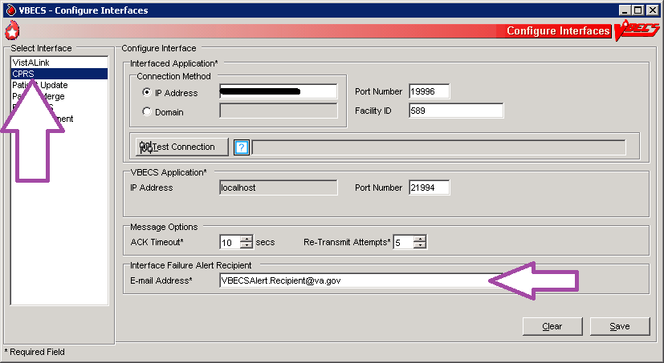

SQL maintenance job alerts are marked with High Importance and must be acted upon immediately. The email will contain details of the failure and instructions for contacting the Service Desk Primary Contact. When a SQL integrity job fails, a report will be included as an attachment with the alert – include this with any support ticket (Service Desk Primary Contact) or communication (Figure 31).

Figure 31: Example of a SQL Maintenance Job Failure Email

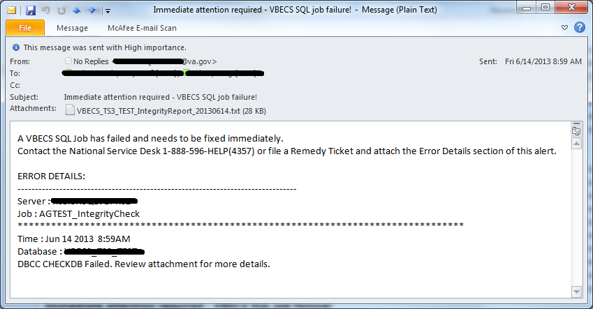

## SQL Database Backups

To assist recovery and support options, database backup files and integrity reports are retained for 7 days for each SQL database and can be found on the SQL Server at **H:\Program Files\Microsoft SQL Server\MSSQL11.MSSQLSERVER\MSSQL\Backup**. If tape or offsite backups are desired, locate and backup the folders associated with the 3-character site code (*SSS*). For example, on a production SQL server, Hines (“HIN” site code) would backup the VBECS_HIN_PROD and VBECS_HIN_PROD_MIRROR folders.

## Applying Windows Updates DR 5186

 App server updates require downtime, which is detailed in Table 6 and Table 7. SQL server updates require no downtime.

The VistA Blood Establishment Computer Software (VBECS) systems are updated with Microsoft Windows Security patches by Austin Information Technology Center (AITC) staff during defined maintenance periods (Table 6 and Table 7).

**The monthly maintenance schedule begins the second Tuesday of the month that Microsoft defines as Patch Tuesday.**

1. Enterprise Operations installs Windows Updates patches to VBECS maintenance team pre-production servers.
2. VBECS maintenance team tests the patched pre-production servers and proves that the updates do not affect VBECS.
3. After the VBECS team approves the updates, Enterprise Operations creates change orders for the customer-test system and another for the production system.
4. Enterprise Operations will submit an ANR and then install the patches, using the approved schedule, on the customer-test systems.
5. Enterprise Operations will submit an ANR and then install the patches, using the approved schedule, on the production systems.

Table 6: Customer Test System Patch Schedule

|  |  |
| --- | --- |
| **Server** | **Day** |
| App Servers | 15 days after patch Tuesday, 10 AM local time (automatic with notification) |
| Product Support Servers | 11 days after patch Tuesday, 8-9 AM CST (manual) |
| SQL Server, Disaster Recovery node | 10 days after patch Tuesday, 8-9 AM CST (manual) |
| SQL Server, High Availability node | 10 days after patch Tuesday, 9-10 AM CST (manual) |
| SQL Server, Primary node | 10 days after patch Tuesday, 10-11 AM CST (manual) |

Table 7: Production System Patch Schedule

|  |  |
| --- | --- |
| **Server** | **Day** |
| Application Servers | 15 days after patch Tuesday, 10 AM local time (automatic with notification) |
| SQL Server, Disaster Recovery node | 15 days after patch Tuesday, 9-10 AM CST (manual) |
| SQL Server, High Availability node | 15 days after patch Tuesday, 10-11 AM CST (manual) |
| SQL Server, Primary node | 15 days after patch Tuesday, 11-12 PM CST (manual) |

The App Servers are updated differently than the SQL Servers:

* **App Servers**: The App Servers are updated and rebooted by an automated process at 10:00am local time on the day of patch release. VBECS users connected to the server receive a warning at the following time intervals: 15 minutes, 10, 5, 4, 3, 2 and 1 (Figure 32).
* If the App Server is not operational by 10:15AM local time, contact the Service Desk Primary Contact.

Figure 32: Example of Server Restart Warning

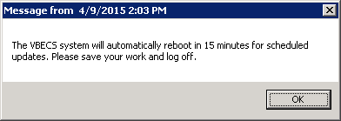

* **SQL Servers**: Due to clustering, the SQL Servers require manual update. The manual process is described in the next section.

## Applying Updates to VBECS SQL Server System

Each VBECS SQL Server system is comprised of three servers that are setup for redundancy with the use of Windows Failover Clustering and the Microsoft SQL AlwaysOn technology:

* Server 1: referred to as the Primary server
* Server 2: local secondary server, referred to as the High Availability (HA) server
* Server 3: remote secondary server, referred to as the Disaster Recovery (DR) server

** Replica is another name for a server within a SQL Server AlwaysOn configuration.

The names of the VBECS SQL servers can be found on the [Data Center Worksheet](https://vaww.sde.portal.va.gov/sites/eo/Products/VHA/VBE/13-100/Executing/VBECS%20PROD%20Data%20Center%20Worksheets%20COMPLETED.doc) (Figure 33).

Figure 33: Example Data Center Worksheet

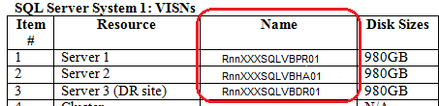

* Failure to adhere to these instructions could result in data loss and/or system failure. Always apply updates to Server 3 first and the Primary Replica last.*

When updating a VBECS SQL Server system, refer to the flowchart in Figure 34 for the proper execution order.

Figure 34: Updating a VBECS SQL Server System Process Flow



*Failover is a term used to describe the process of changing which server in a SQL AlwaysOn configuration is designated as the Primary Replica. Never use the following instructions to failover to Server 3 (DR Server). Instructions for forcing a failover to Server 3 are provided in the VBECS Disaster and Recovery guide.*

*A Server Administrator should only initiate manual failover when client usage of the system is minimal. Users may briefly lose VBECS database connectivity depending on how long the failover takes.*

**Apply Updates to Server 3**

1. Open a remote desktop connection to Server 3 of the VBECS SQL Server system.
2. Apply the Windows/Software Updates using the supplied instructions for the updates (reboot Server 3 only if instructed).

**Identify the Primary and Secondary Replica**

1. Open a remote desktop connection to Server 1 of the VBECS SQL Server system. On the Start menu, click **All Programs, Microsoft SQL Server 2012, SQL Server Management Studio**.
2. When prompted to connect to a server, enter the name of Server 1 in the **Server Name** field and click **Connect** (Figure 35). Note 1: VBECS Test system SQL Servers are named differently than production SQL servers. Note 2: If you have issues connecting, use the fully qualified domain name.

Figure 35: Example of the Connect to SQL Server Window

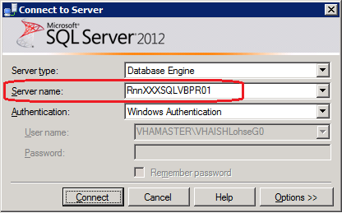

1. On the left side of the SQL Server Management Studio (SSMS) screen is the Object Explorer pane. Within the Object Explorer pane, right-click on the A**lwaysOn High Availability** folder and select **Show Dashboard** (Figure 36).

Figure 36: Example of Launching the SQL Dashboard

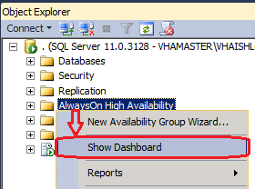

1. A Dashboard tab (Figure 37) displays the Primary Instance and Failover Mode of the VBECS SQL Availability Groups (AG). Each AG has one of the following status indicator icons:

: your SSMS is connected to the AG’s Primary Instance server (i.e., the Primary Replica)

: your SSMS is not connected to the AG's Primary Instance server

: there is a severe issue with the AG

Figure 37: Example of the SQL Server Dashboard

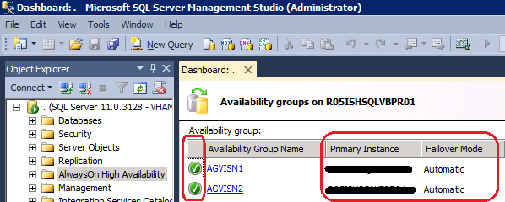

* If any Availability Group status indicators are  or if there are a mix of  and  indicators, VBECS is down and the problem must be resolved immediately.*

1. If all of the indicators are , close SSMS. Restart at Step 3 connecting to the server listed in the Primary Instance column.
2. Make a note of the Primary and Secondary Replicas (i.e., if Server 1 is the Primary Replica, then Server 2 is the Secondary Replica and visa-versa).

**Create Backups**

1. Now that all of the AGs are running under the Primary Replica, navigate to and expand the **SQL Server Agent, Jobs** folder in the Object Explorer pane.
2. Double-click on **Job Activity Monitor**.
3. In the Job Activity window, click the  button (Figure 38).

Figure 38: Example of Job Activity Monitor

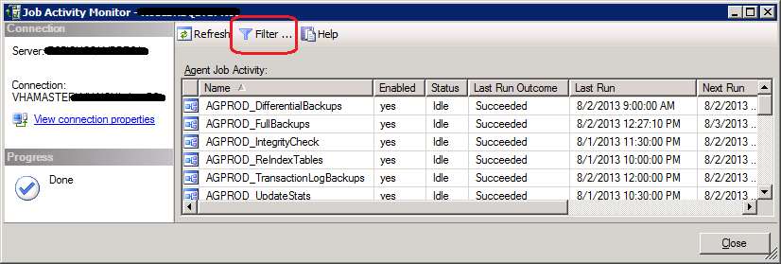

1. In the Filter Settings window, enter **full** in the **Name** field, check the **Apply filter** box and click **OK** (Figure 39).

Figure 39: Filter Settings

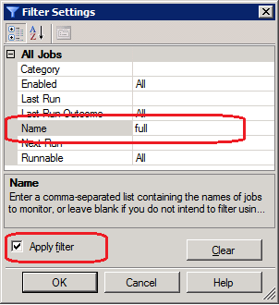

1. Right-click the first job in the filtered list and select **Start Job at Step…** (Figure 40).

Figure 40: Example Starting a SQL Job

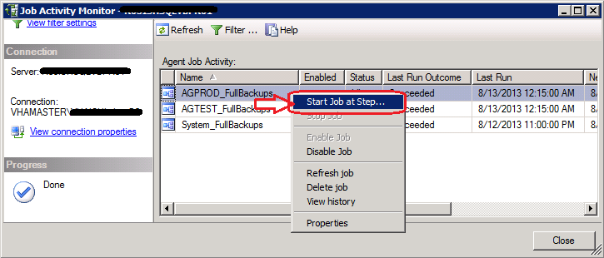

1. Wait for the job to finish (Figure 41). Verify the status indicator is **Success** before clicking **Close**.

Figure 41: Example Job Completion Message

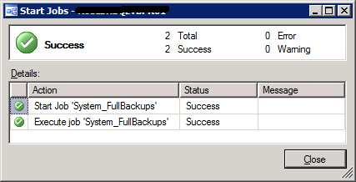

1. Repeat Steps 13 and 14 for each job in the list.

* If any of the jobs fail to complete successfully, please notify the appropriate support personnel immediately by contacting the Service Desk Primary Contact*.

1. Click **Close** on the Job Activity Monitor window.

**Change the Failover Mode from Automatic to Manual**

1. In the Object Explorer pane, navigate to and expand the **AlwaysOn High Availability**, **Availability Groups** folder**.**
2. Right-click on the first AG and select **Properties**; the Availability Group Properties window opens.
3. Locate the two servers with an Availability Mode of **Synchronous commit** (Figure 42). Change both **Failover Mode** cells from Automatic to **Manual** and click **OK**. If the fields are greyed-out, you are not connected to the Primary Replica: close SSMS, logoff the server and restart at Step 3.

Figure 42: Example of the Availability Group Properties

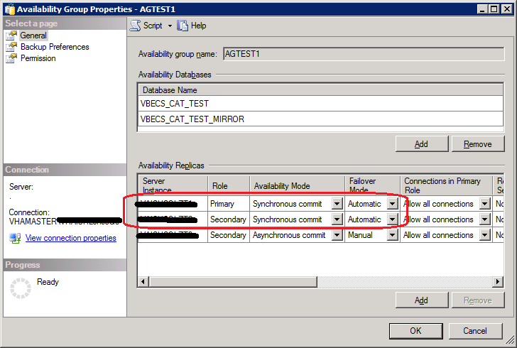

1. Repeat Steps 18 and 19 for each AG on the server until each has their **Failover Mode** set to **Manual**.
2. Close SSMS.

*To prevent an unintentional automatic failover during the upgrade process, the Failover Mode must be set to Manual on each replica before performing a Manual Failover of the Availability Groups.*

**Apply Updates to the Secondary Replica**

1. Open a remote desktop connection to the Secondary Replica identified in Step 8 of the VBECS SQL Server system.
2. Apply the Windows/Software Updates using the supplied instructions for the updates (reboot the server only if instructed).

**Failover the Availability Groups to the Secondary Replica**

1. Open SSMS and connect to the Secondary Replica noted in Step 8.
2. Inside the Object Explorer pane, navigate to and expand the **AlwaysOn High Availability**, **Availability Groups** folder**.**
3. Right-click on the first AG and select **Failover…**; an Availability Group Failover wizard starts.
4. Click **Next** (Figure 43).

Figure 43: Example of the Availability Group Failover Wizard

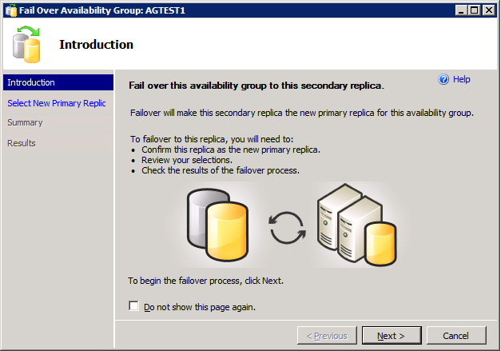

1. Verify the Failover Mode is **Manual** and Failover Readiness is **No data loss**. Click **Next** (Figure 44). Note: If two servers appear in the list, then you are connected to the Primary Replica. Click **Cancel** and close SSMS. Restart at Step 24.

Figure 44: Example of Selecting the New Primary Replica

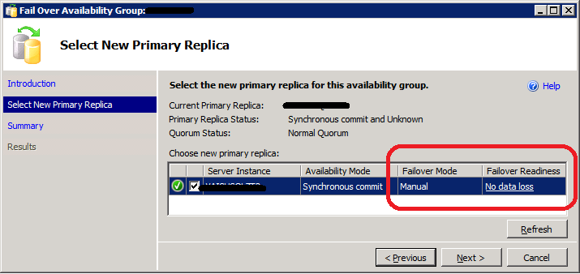

* If* *the Failover Readiness field is not in a state of* ***No data loss****, notify SQL Server support personnel immediately by contacting the Service Desk Primary Contact*.

1. A Summary window is displayed (Figure 45). If any of the field values are incorrect (Failover Actions must be No data loss), click **Cancel** and close SSMS. Restart at Step 24.

Figure 45: Example of Availability Group Failover Wizard Summary

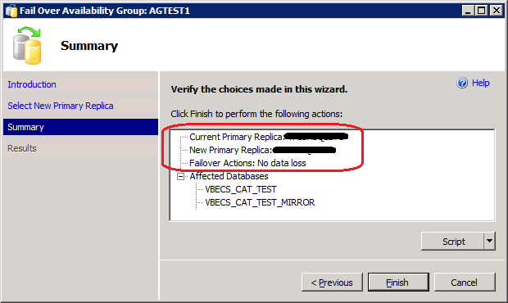

1. Click **Finish** to initiate the failover.
2. A failover may take several minutes to complete. Click **Close** (Figure 46).

Figure 46: Example of Successful Failover Wizard

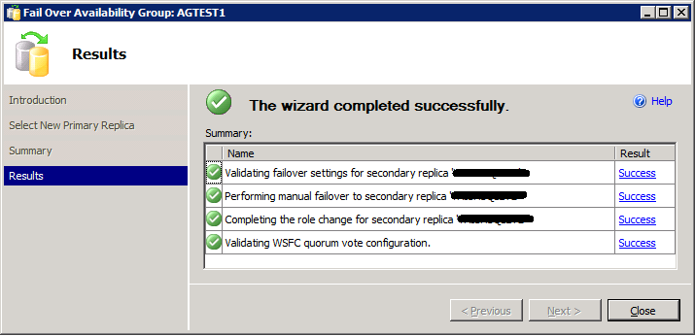

 If any of the Results indicate Error, Warning or Failure, contact SQL Server support personnel by contacting the Service Desk Primary Contact. Databases contained in the problem Availability Group will not be available for use until the problem is resolved.

1. Repeat Steps 26 through 31 for each AG on the server.
2. Close SSMS.

**Apply Updates to the Remaining Server (Original Primary Replica)**

1. Open a remote desktop connection to the Original Primary Replica (identified in Step 8) of the VBECS SQL Server system.
2. Apply the Windows/Software Updates using the supplied instructions for the updates (reboot the server only if instructed).

**Failover the Availability Groups Back to the Original Primary Replica**

1. Open SSMS and connect to the Primary Replica noted in Step 8.
2. Inside the Object Explorer pane, navigate to and expand the **AlwaysOn High Availability**, **Availability Groups** folder**.**
3. Right-click on the first AG and select **Failover…**; an Availability Group Failover wizard starts. Click **Next** (Figure 43).
4. Verify the Failover Mode is **Manual** and Failover Readiness is **No data loss**. Click **Next** (Figure 44). If two servers appear in the list, then you are connected to the Secondary Replica. Click **Cancel** and close SSMS. Restart at Step 36.

* If* *the Failover Readiness field is anything other than* ***No data loss****, contact SQL Server support personnel (contact the Service Desk Primary Contact)*.

1. A Summary window is displayed (Figure 45). If any of the field values are incorrect (Failover Actions must be No data loss), click **Cancel** and close SSMS. Restart at Step 36.
2. Click **Finish** to initiate the failover.
3. The failover may take several minutes to complete. Click **Close** (Figure 46).

 If any of the Results indicate Error, Warning or Failure. Databases contained in the problem, contact SQL Server support personnel (contact the Service Desk Primary Contact). Availability Group will not be available for use until the problem is resolved.

1. Repeat Steps 28 through 42 for each AG on the server.

**Change the Failover Mode from Manual to Automatic**

1. Right-click on the first AG and select **Properties**; the Availability Group Properties window open.
2. Locate the two servers with an Availability Mode of **Synchronous commit** (Figure 47). Change both **Failover Mode** cells from **Manual** to **Automatic** and click **OK**.

Figure 47: Example of the Availability Group Properties

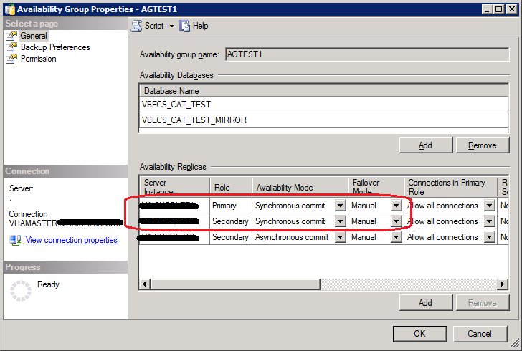

1. Repeat Steps 44 and 45 for each AG on the server until each has their **Failover Mode** set to **Automatic**.
2. Close SSMS and log off the server.

## ePolicy and Virus Definitions

Virus definitions are automatically updated on the VBECS system. The VBECS maintenance team monitors the releases.

 Do not change the system!The U.S. Food and Drug Administration classifies this software as a medical device. Unauthorized modifications will render this device an adulterated medical device under Section 501 of the Medical Device Amendments to the Federal Food, Drug, and Cosmetic Act. Acquiring and implementing this software through the Freedom of Information Act require the implementer to assume total responsibility for the software and become a registered manufacturer of a medical device, subject to FDA regulations. Adding to or updating VBECS software without permission is prohibited.

# VistA Maintenance Operations

Four HL7 Logical Links and one VistALink connection must be established and configured to establish proper communication with VBECS. The HL7 links are OERR-VBECS, VBECS-OERR, VBECSPTU, and VBECSPTM. The VistALink connection configuration is the data that VistA will use to transmit data in XML format to VBECS. The following set of instructions will aid in the proper configuration of these links, and ensure reliable communication between VistA and VBECS. These links must be configured during the initial installation of VBECS, and after any changes to the HL7 or VistALink configuration on VBECS. The settings should also be updated after the VistA Test account has been remirrored.

## Set Up VBECS Outbound Logical Links

1. At the “Select HL7 Main Menu Option:” prompt, enter **Filer**.
2. Shut down the logical link.
3. At the “Select Filer and Link Management Options Option:” prompt, enter **Link Edit**.
4. At the “Select HL LOGICAL LINK NODE:” prompt, enter **OERR-VBECS** (Figure 48).

Figure 48: HL7 Logical Link Edit Menu Navigation

|  |
| --- |
| HL7 Main Menu  Event monitoring menu ...  Systems Link Monitor  **Filer and Link Management Options ...**  Message Management Options ...  Interface Developer Options ...  Site Parameter Edit  Select HL7 Main Menu Option: **FILER**  SM Systems Link Monitor  FM Monitor, Start, Stop Filers  LM TCP Link Manager Start/Stop  SA Stop All Messaging Background Processes  RA Restart/Start All Links and Filers  DF Default Filers Startup  SL Start/Stop Links  PI Ping (TCP Only)  **ED Link Edit**  ER Link Errors ...  Select Filer and Link Management Options Option: **ED**  Select HL LOGICAL LINK NODE: **OERR-VBECS** |

1. Enter **Enabled** in the AUTOSTART field (Figure 49).
2. Move the cursor to the LLP TYPE field and press **Enter** (Figure 49).

Figure 49: HL7 Logical Link

HL7 LOGICAL LINK

-----------------------------------------------------------------------------

NODE: **OERR-VBECS**

INSTITUTION:

DOMAIN:

AUTOSTART: **ENABLED**

QUEUE SIZE: 10

LLP TYPE: TCP

______________________________________________________________________________

COMMAND: Press <PF1>H for help Insert

1. Change the value of the “TCP/IP ADDRESS” and “TCP/IP PORT” parameters to the Internet Protocol (IP) address and port number of the Blood Bank medical device application server at your site. Standard port numbers of 21993 for Test and 21994 for Prod are typically used.
2. Move the cursor to the “COMMAND:” prompt.
3. Enter **Close** to return to the previous screen.
4. At the “COMMAND:” prompt, enter **Save**.
5. Enter **Exit**.

Figure 50: TCP Lower Level Parameters: OERR-VBECS

HL7 LOGICAL LINK

-----------------------------------------------------------------------------

TCP LOWER LEVEL PARAMETERS

**OERR-VBECS**

TCP/IP SERVICE TYPE: CLIENT (SENDER)

TCP/IP ADDRESS: <IP address of VBECS application server>

TCP/IP PORT: <Port number of VBECS application server>

ACK TIMEOUT: 30 RE-TRANSMISION ATTEMPTS:

READ TIMEOUT: 30 EXCEED RE-TRANSMIT ACTION: restart

BLOCK SIZE: SAY HELO:

STARTUP NODE: PERSISTENT: NO

RETENTION: 15 UNI-DIRECTIONAL WAIT:

____________________________________________________________________________

COMMAND: Press <PF1>H for help Insert

1. Repeat Steps 3 through 11 substituting “VBECSPTM” and “VBECSPTU” for “OERR-VBECS” when prompted for the logical link name to change the IP address and port numbers for the VBECSPTM and VBECSPTU logical links.

## Set Up the VBECS Inbound Logical Link

1. At the “Select HL7 Main Menu Option:” prompt, enter **Filer**.
2. At the “Select Filer and Link Management Options Option:” prompt, enter **Link Edit**.
3. At the “Select HL LOGICAL LINK NODE:” prompt, enter **VBECS-OERR** (as shown for OERR-VBECS in Figure 48).
4. Enter **Enabled** in the AUTOSTART field (Figure 51).
5. Move the cursor to the LLP TYPE field and press **Enter** (Figure 51).

Figure 51: HL7 Logical Link

HL7 LOGICAL LINK

-----------------------------------------------------------------------------

NODE: **VBECS-OERR**

INSTITUTION:

DOMAIN:

AUTOSTART: **ENABLED**

QUEUE SIZE: 10

LLP TYPE: TCP

_____________________________________________________________________________

COMMAND: Press <PF1>H for help Insert

1. No “TCP/IP ADDRESS” should be entered. Change the value of the “TCP/IP PORT” parameter to the port number of the VistA HL7 Listener at your site. Regional support should be contacted for the correct port numbers. Standard port numbers of 21993 for Test and 21994 for Prod can be used if unique ports have not been assigned.
2. Move the cursor to the “COMMAND:” prompt.
3. Enter **Close** to return to the previous screen.
4. At the “COMMAND:” prompt, enter **Save**.
5. Enter **Exit**.

Figure 52: TCP Lower Level Parameters: VBECS-OERR

HL7 LOGICAL LINK

-----------------------------------------------------------------------------

TCP LOWER LEVEL PARAMETERS

**VBECS-OERR**

TCP/IP SERVICE TYPE: SINGLE LISTENER

TCP/IP ADDRESS:

TCP/IP PORT: *<VistA HL7 Listener Port>*

ACK TIMEOUT: 30 RE-TRANSMISION ATTEMPTS:

READ TIMEOUT: 30 EXCEED RE-TRANSMIT ACTION:

BLOCK SIZE: SAY HELO:

STARTUP NODE: PERSISTENT: NO

RETENTION: UNI-DIRECTIONAL WAIT:

____________________________________________________________________________

COMMAND: Press <PF1>H for help Insert

## Start VistA HL7 Logical Links

1. Before data can be transmitted over the VBECS logical links, edit the link definitions as described above.
2. To turn on the new VBECS logical links, select **Start/Stop Links [HL START]**.
3. Start the “OERR-VBECS” logical link.
4. Start the “VBECS-OERR” logical link.
5. Start the “VBECSPTM” logical link.
6. Start the “VBECSPTU” logical link.
7. Ensure that the VistA HL7 Link Manager is running; VBECS messaging cannot occur without it.
8. To check the status of the Link Manager (and, if necessary, restart it), access the **HL START/STOP LINK MANAGER** menu option.

## Monitor VBECS HL7 Logical Links

Once two-way communication has been established, you can monitor the links.

1. Use the “System Link Monitor” to view the status of the VBECS Logical Links.
2. From the “HL7 Main Menu”, select **System Link Monitor** (Figure 53).

Figure 53: HL7 System Link Monitor Menu Navigation

|  |
| --- |
| HL7 Main Menu  Event monitoring menu ...  **Systems Link Monitor**  Filer and Link Management Options ...  Message Management Options ...  Interface Developer Options ...  Site Parameter Edit  Select HL7 Main Menu Option: **System Link Monitor** |

1. When a list of VistA HL7 links defined at your site appears, press **V** at the “Select a Command:”prompt (Figure 54).
2. At the “Select LINK MONITOR VIEWS:” prompt, enter **VBECS** (Figure 54).

Figure 54: System Link Monitor

SYSTEM LINK MONITOR for <your site name>

MESSAGES MESSAGES MESSAGES MESSAGES DEVICE

NODE RECEIVED PROCESSED TO SEND SENT TYPE STATE

LA7V 657 4 4 MM Halting

LL15VISN 105 105 394 105 NC Shutdown

MPIVA 0 0 322 0 NC Shutdown

NPTF 0 0 25 0 MM Halting

OERR-VBE 34 34 1019 1018 NC Idle

PSOTPBAA 28 28 52 28 NC Shutdown

VABAC 0 0 1 0 NC Shutdown

VAFAV 0 0 2 0 NC Shutdown

VAFHM 0 0 3 0 NC Shutdown

VAFRE 0 0 4 0 NC Shutdown

Incoming filers running => 1 TaskMan running

Outgoing filers running => 1 Link Manager running

Monitor OVERDUE

Select a Command:

(N)EXT (B)ACKUP (A)LL LINKS (S)CREENED (V)IEWS (Q)UIT (?) HELP: **V**

Select LINK MONITOR VIEWS: **VBECS**

1. A screen similar to Figure 55 appears.

Figure 55: System Link Monitor

SYSTEM LINK MONITOR for <your site name>

MESSAGES MESSAGES MESSAGES MESSAGES DEVICE

NODE RECEIVED PROCESSED TO SEND SENT TYPE STATE

OERR-VBECS 0 0 0 0 NC Idle

VBECS-OERR 0 0 0 0 SS Idle

VBECSPTM 0 0 0 0 NC Enabled

VBECSPTU 0 0 0 0 NC Enabled

Incoming filers running => 1 TaskMan running

Outgoing filers running => 1 Link Manager Running

Monitor OVERDUE

Select a Command:

(N)EXT (B)ACKUP (A)LL LINKS (S)CREENED (V)IEWS (Q)UIT (?) HELP:

1. To exit the “System Link Monitor”, at the “Select a Command:” prompt, enter **q** to quit.

 The volume of HL7 traffic over these links depends on the number of daily CPRS Blood Bank orders and updates to the VistA clinical information at your site. These can be significant at large sites. Monitor the links closely the first few days after the installation and purge the HL7 log data (as appropriate) in accordance with your standard HL7 monitoring and purging procedures.

## Configure VBECS VistALink Links

1. Use the “Edit Parameter Values” option on the “GENERAL PARAMETER TOOLS” menu to edit the values for the VistALink connection to VBECS.
2. At the “Select Instance:” prompt, enter **LISTENER IP ADDRESS**.
3. At the “Value:” prompt, enter the VBECS application server IP address.
4. At the “Select Instance:” prompt, enter **LISTENER PORT NUMBER**.
5. At the “Value:” prompt, enter the VBECS VistALink listener port number. This is typically 21991 for Test and 21992 for Prod.
6. Press Enter to exit the option.

Figure 56: VistALink Configuration

Select OPTION NAME: **GENERAL PARAMETER TOOLS** XPAR MENU TOOLS General Parameter Tools

LV List Values for a Selected Parameter

LE List Values for a Selected Entity

LP List Values for a Selected Package

LT List Values for a Selected Template

EP Edit Parameter Values

ET Edit Parameter Values with Template

EK Edit Parameter Definition Keyword

Select General Parameter Tools Option: **EP** Edit Parameter Values

--- Edit Parameter Values

Select PARAMETER DEFINITION NAME: **VBECS VISTALINK**

---------------- Setting VBECS VISTALINK for Package: VBECS

Select Instance: **LISTENER IP ADDRESS**

Instance: LISTENER IP ADDRESS// LISTENER IP ADDRESS

Value: <IP address>// **🡨 Enter the VBECS application server IP address here.**

Select Instance: LISTENER PORT NUMBER

Instance: **LISTENER PORT NUMBER** Replace LISTENER PORT NUMBER

Value: 8000// **🡨Enter the VBECS VistALink listener port here.**

Select Instance:

## VBECS Maintenance Operations

These maintenance operations are performed, using the VBECS Administrator software, during the initial installation of VBECS and during post-installation maintenance activities.

When VBECS Administrator is used for the first time, Configure Interfaces is the only option available. Completion of Configure Interfaces enables Configure Divisions. Completion of Configure Divisions enables Configure Users.

Configured options will be available at startup to perform maintenance operations. Only one instance of the VBECS Administrator can run at a time.

VBECS Administrator does not allow IAM access through e-token.

 MBR_1.10, MBR_1.11 The dialogs defined in Configure Interfaces and Configure Divisions cannot run when VBECS is operational. VBECS cannot run when a dialog in these options is operational.

 Do not change the system!The U.S. Food and Drug Administration classifies this software as a medical device. Unauthorized modifications will render this device an adulterated medical device under Section 501 of the Medical Device Amendments to the Federal Food, Drug, and Cosmetic Act. Acquiring and implementing this software through the Freedom of Information Act require the implementer to assume total responsibility for the software and become a registered manufacturer of a medical device, subject to FDA regulations. Adding to or updating VBECS software without permission is prohibited.

#### Prerequisites

VistALink is installed and running on the associated VistA system.

The user is defined in VistA, has a DUZ and connectivity to VistA can be established.

The user has a valid Windows account and is defined as a member of the VBECS Administrator Active Directory (AD) domain group.

The VBECS database is installed and operational.

The VBECS Outbound logical links have been set up.

The VBECS Inbound Logical Link has been set up.

The VistA HL7 Logical Links have been started.

The VBECS HL7 Logical Links are being monitored.

If using an automated instrument, the supporting drivers must be installed.

#### Outcome

Parameters necessary to establish the connection to VistA through VistALink are available to the main VBECS application, as defined in the Configure Interfaces option.

VBECS-VistA HL7 interface parameters are defined in the Configure Interfaces option.

One or more divisions are defined for use in VBECS in the Configure Divisions option.

One or more divisions are activated as local facilities in VBECS in the Configure Divisions option.

The VBECS Administrator has VBECS login[1] access to all active divisions.

VBECS users are defined and able to use VBECS in the Configure Users option.

#### Limitations and Restrictions

 When the division changes from full-service to transfusion-only or from transfusion-only to full-service, information must be in a final state and eXM must be disabled.

#### Additional Information

Refer to the completed Appendix: Configuration Worksheet in *VBECS Application Interfacing Support Software Installation and User Configuration Guide* for required information when performing maintenance operations.

#### User Roles with Access to This Application

VBECS Administrator

#### Log into VBECS Administrator

The VBECS Administrator performing the initial installation and setup must have the XOBV VISTALINK TESTER and VBECS VISTALINK CONTEXT options defined as secondary options in VistA.

| **User Action** | **VBECS Administrator** |
| --- | --- |
| 1. Open a **Remote Desktop Connection**.   . | * Displays the Remote Desktop Connection screen. |
| 1. Enter or select the name of the VBECS Application Server on the **Remote Desktop Connection** (Figure 57) screen and click **Connect**. | * Displays Security Warning screen. |
| 1. Click **OK** on the Security Warning screen. | * Displays Log On to Windows screen. |
| 1. Use PIV and PIN to enter the Remote Desktop Session (Figure 58 and Figure 59). | * Displays VBECS server desktop with VBECS Admin Prod and VBECS Admin Test icons.   **NOTES**  Users will see several certificates listed during the sign on process. User should select the last certificate with their name from the list of certificates. |
| 1. Double-click the VBECS Admin Prod icon. | * Opens VBECS Administrator.   **NOTES**   * When the user logs into VBECS Administrator for the first time to set VistALink parameters, the system does not require IAM certificate/PIN or VistA Access and Verify Code selection. Continue at Step 8. |
| 1. Use PIV and PIN to connect to VistA when VBECS Administrator starts up or at the invocation of any option that uses VistALink when VistALink is not connected (Figure 58 and Figure 59).   If the IAM PIV sign on process succeeds, continue at Step 8.  If the IAM PIV sign on process fails, continue at next step. | * BR_102.06 The user may log onto VistA or continue and log on as needed. * Directs user to the IAM service interface to select PIV certificate and possibly to re-enter PIN. * If the IAM PIV sign on process fails, VBECS continues to the next step and prompts user for VistA Access and Verify Code. The user may log onto VistA or continue and log on as needed.   **NOTES**  DR 1,116The system prompts the user for their Access and Verify Code when there is no active IAM service certification.  BR_103.02 The VistA logon screen is displayed only after initial setup of VistALink parameters. |
| 1. Enter the VistA Access and Verify Codes (Figure 60). | * Opens the VistA Logon – Authorization screen. The user may log onto VistA or continue and log on as needed. * Allows a user to log on by entering VistA Access and Verify Codes, separated by a semicolon (;), in the Access Code data entry field. * Verifies that the user credentials for the VBECS and VistA Access and Verify Codes belong to the same user.   **NOTES**  DR 1,116When a user logs into VBECS Administrator, the connection to VistA is established through VistALink.   * BR_103.02 |
| 1. Continue working in VBECS Administrator (Figure 61). | * Displays the main menu. |

Figure 57: Remote Desktop Connection Options

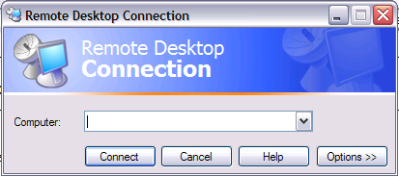

Figure 58: IAM – PIV Certificate

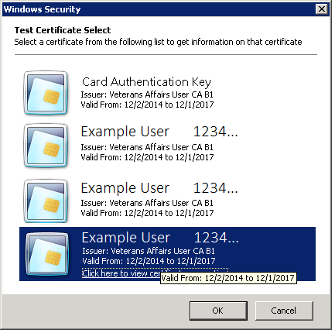

Figure 59: ActivClient Login

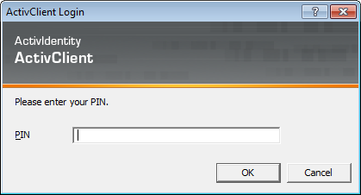

Figure 60: Example of VistA Logon

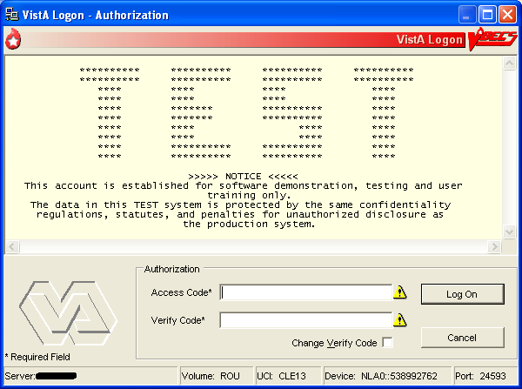

Figure 61: Example of VBECS Administrator

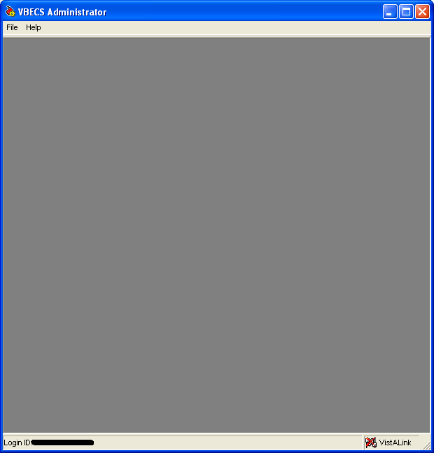

## Configure Interfaces

The VBECS Administrator sets parameters for the connection to VistA to enable retrieval of VistA data, to configure HL7 interfaces between VBECS and VistA, to enable and configure the BCE interface and to configure the Automated Instrument interface.

| **User Action** | **VBECS Administrator** |
| --- | --- |
| 1. To configure VBECS VistALink, HL7, Patient Update, Patient Merge, BCE and Auto Instrument interface parameters, click **File** on the main menu of the VBECS Administrator software. | * Displays the menu options used to configure VBECS. |
| 1. Click **Configure Interfaces** (Figure 62). | * Displays the VBECS Configure Interfaces dialog for data entry. |

Figure 62: Example of Configure Interfaces

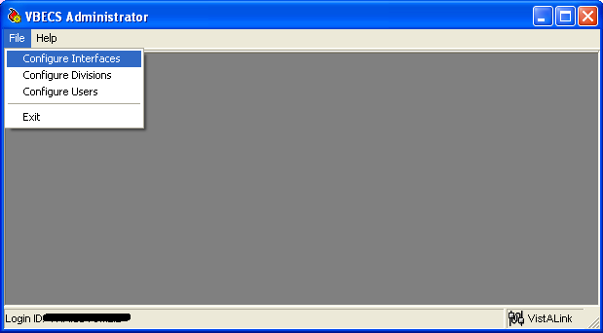

#### Configure VistALink Parameters

| **User Action** | **VBECS Administrator** |
| --- | --- |
| 1. To configure VistALink Parameters, click **File** on the menu of the VBECS Administrator software. | * Displays the menu options used to configure VBECS. |
| 1. Click **Configure Interfaces**. | * Displays the VBECS Configure Interfaces dialog for data entry. |
| 1. To configure VistALink parameters, select **VistALink** from the Select Interface list box (Figure 63). | * Displays the Configure VistALink group and allows data entry of the IP address (or domain name) and port number of the VistA system VistALink listener.   **NOTES**  The user may modify the IP address (or domain name) and port number, as required. |
| 1. For the VistALink interface, enter a valid IP address (or domain name) and port number of the VistA system VistALink listener in the M Server group box fields. | * Validates that the IP address is in the standard four-octet notation (e.g., 127.0.0.1) or that the Domain field was filled in. * Validates that the port number is a whole number from 1024 to 65535.   **NOTES**   * The IP Address field represents the VistALink IP address. * The Port Number field represents the port on which the VistALink Listener is running. |
| 1. Click **Test Connection**.   Record the IP and port numbers. | **NOTES**  The Test Connection button is enabled only when valid entries exist in the IP Address (or Domain) and Port Number fields.  If connection to the VistA system is successful, the VistA Logon – Authorization dialog is displayed and the user is required to select IAM/PIN or enter valid Access and Verify Codes.  If connection to the VistA system is unsuccessful, hover over the red square and a detailed error message will display. |
| 1. To configure the VBECS VistALink Service, enter a valid IP and port number.   Capture a screen shot. | * Validates that the IP address is in the standard four-octet notation (e.g., 127.0.0.1). * Validates that the port number is a whole number from 1024 to 65535.   **NOTES**  The IP Address field represents the VBECS application server IP address.  The Port Number field represents the port on which the VBECS VistALink Service is running. This is typically 21991 for Test and 21992 for Prod. |
| 1. Click **Save** to save changes. | * Displays a confirmation dialog. Also warns the user that the VBECS VistALink service will be restarted if parameters changed. |
| 1. Click **Yes** to commit changes to the database. | Changes are saved to the VBECS database and VBECS will attempt to restart the VBECS Prod (or Test) VistALink Listener service if the IP or Port Number has changed.  If the restart fails, you will receive the following message: **The service failed to restart. Please contact VBECS support to have the service restarted**. If you receive the failure message, please file a support ticket (Service Desk Primary Contact). |

Figure 63: Example of Configure Interfaces: VistALink (showing VBECS Prod Port Number)

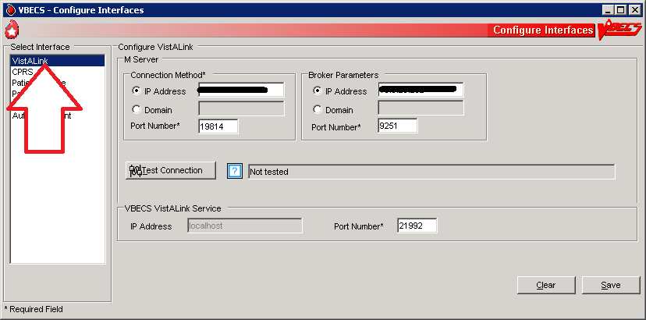

#### Configure Broker Parameters

| **User Action** | **VBECS Administrator** |
| --- | --- |
| 1. To configure Broker Parameters, click **File** on the menu of the VBECS Administrator software. | * Displays the menu options used to configure VBECS. |
| 1. Click **Configure Interfaces**. | * Displays the VBECS Configure Interfaces dialog for data entry. |
| 1. To configure Broker parameters, select **VistALink** from the Select Interface list box (Figure 63). | * Displays the Configure Broker group and allows data entry of the IP address (or domain name) and port number of the VistA broker.   **NOTES**  The user may modify the IP address (or domain name) and port number, as required. |
| 1. For the Broker interface, enter a valid IP address (or domain name) and port number of the VistA Broker (see Figure 64 for instructions on obtaining a valid VistA Broker IP/Port). | * Validates that the IP address is in the standard four-octet notation (e.g., 127.0.0.1) or that the Domain field was filled in. * Validates that the port number is a whole number from 1024 to 65535.   **NOTES**   * The IP Address field represents the Broker IP address. * The Port Number field represents the port on which the VistA Broker is running. |
| 1. Click **Save** to save changes. | * Displays a confirmation dialog. Also warns the user that the VistALink service will be restarted if parameters changed. |
| 1. Click **Yes** to commit changes to the database. | Changes are saved to the VBECS database and VBECS will attempt to restart the VBECS Prod (or Test) VistALink Listener service if the IP or Port Number has changed.  If the restart fails, you will receive the following message: **The service failed to restart. Please contact VBECS support to have the service restarted**. If you receive the failure message, please file a support ticket (Service Desk Primary Contact). |

#### 

#### Figure 64: Example of Collecting VistA Broker Values from a CPRS Shortcut

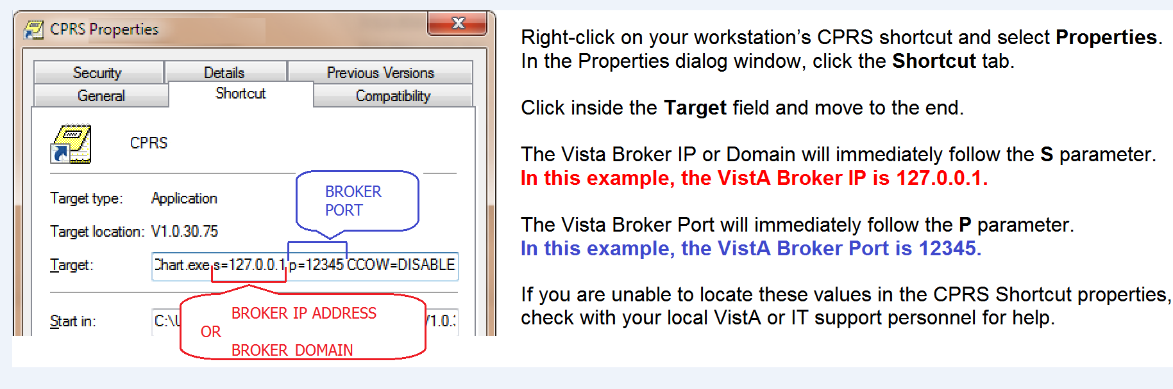

**Configure CPRS HL7 Interface Parameters**

| **User Action** | **VBECS Administrator** |
| --- | --- |
| 1. To configure CPRS HL7 Interface Parameters, click **File** on the menu of the VBECS Administrator software. | * Displays the menu options used to configure VBECS. |
| 1. Click **Configure Interfaces**. | * Displays the VBECS Configure Interfaces dialog for data entry. |
| 1. To configure CPRS HL7 Interface Parameters, select **CPRS** from the Select Interface list box in the VBECS – Configure Interfaces dialog (Figure 65). | * Displays the Configure Interface group and allows data entry of HL7 interface-related parameters. |
| 1. To configure Interfaced Application group parameters, enter a valid IP address, port number, and facility ID in the related data fields. | * Validates that the IP address is in the standard four-octet notation (e.g., 127.0.0.1) or that the Domain field was filled in. * Validates that the port number is a whole number from 1024 to 65535.   **NOTES**  The IP Address field represents the VistA IP address to which VBECS will direct messages to CPRS via the VBECS-OERR HL7 Link. The Domain name field represents the fully qualified domain name to which VBECS will direct messages.  The Port Number field represents the VistA port number to which VBECS will direct messages.  The Facility ID is used in the MSH segment of the HL7 interface to help identify the system. This free-text field is usually set to the primary site’s station number. Messaging to VBECS will fail if this Facility ID is not supplied. |
| 1. To configure VBECS Application group parameters a port number in the data field. | * Validates that the port number is a whole number from 1024 to 65535.   **NOTES**  The Port Number field represents the VBECS application server port number of the VBECS HL7 Listener. This is typically 21993 for Test and 21994 for Prod. |
| 1. Click **Test Connection**.   Record the port numbers.  Capture a screen shot. | **NOTES**  The Test Connection button is enabled only when valid entries exist in the IP Address (or Domain) and Port Number fields.  If connection to the CPRS system is unsuccessful, hover over the red square and a detailed error message will display. |
| (This step is optional.)   1. To configure Message Options group parameters, enter an ACK timeout period and a number of retransmission attempts in the related data fields. | * Validates that the ACK timeout period is a whole number from 1 to 999 (seconds) (default: 10). * Validates that the number of retransmission attempts for failed messages is a whole number from 1 to 99 (default: 5). |
| 1. To configure the Interface Failure Alert Recipient group parameter, enter a valid **Administrator distribution** **(Active Directory)** **group** email address in the related data field.   Capture a screen shot. | * Validates the email address is entered correctly.   **NOTES**  Only one email address can be entered which is recommended to contain local IRM support and/or the Blood Bank ADPAC. VBECS Windows Services will send email alerts to this address when HL7 order messaging errors occur.  Email alerts will not contain PII or PHI.  For assistance troubleshooting the email alerts, see the VBECS Application Interfaces section.  This email address is also used for notifications concerning database problems. See the SQL Maintenance section. |
| 1. Click **Save** and **Yes** to confirm the save and service restart and related parameters were changed. | Changes are saved to the VBECS database and VBECS will attempt to restart the VBECS Prod (or Test) HL7 Dispatcher and/or the VBECS Prod (or Test) HL7 Listener if the IP or Port Number has changed for the respective service.  If the restart(s) fail, you will receive the following message: **The service failed to restart. Please contact VBECS support to have the service restarted**. If you receive the failure message, please file a support ticket (Service Desk Primary Contact). |
| 1. To close the VBECS – Configure Interfaces dialog, click **X** in the upper-right corner. | * Validates that the data was saved. |

Figure 65: Example of Configure Interfaces: CPRS (showing Prod Port Numbers)

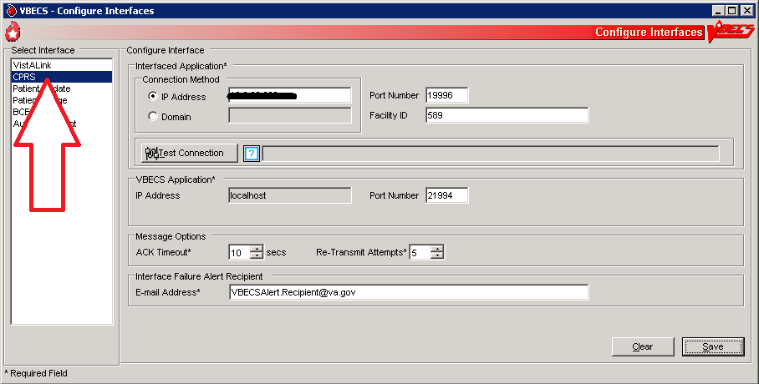

#### Configure Patient Update HL7 Interface Parameters

| **User Action** | **VBECS Administrator** |
| --- | --- |
| 1. To configure Patient Update HL7 Interface Parameters, click **File** on the menu of the VBECS Administrator software. | * Displays the menu options used to configure VBECS. |
| 1. Click **Configure Interfaces**. | * Displays the VBECS Configure Interfaces dialog for data entry. |
| 1. To configure Patient Update HL7 Interface Parameters, select **PatientUpdate** from the Select Interface list box in the VBECS – Configure Interfaces dialog (Figure 66). | * Displays the Configure Interface group and allows data entry of HL7 interface-related parameters. |
| 1. To configure Interfaced Application group parameters, enter a facility ID in the related data fields. | **NOTES**  The IP Address and Port Number fields are disabled: no outbound messages are sent to VistA for this interface.  The facility ID is used in the MSH segment of the HL7 interface to help identify the system. This is a free-text field set to the primary site’s station number. Messaging to VBECS will fail if this Facility ID is not supplied. |
| 1. To configure VBECS Application group parameters, enter a valid port number in the data field. | * Validates that the port number is a whole number from 1024 to 65535.   **NOTES**  The Port Number field represents the VBECS application server port number to which VistA will direct messages. This is typically 21993 for Test and 21994 for Prod. |
| (This step is optional.)   1. To configure Message Options group parameters, enter an ACK Timeout period and number of retransmission attempts in the related data fields. | * Validates that the ACK timeout period is a whole number from 1 to 999 (seconds) (default: 10). * Validates that the number of retransmission attempts for failed messages is a whole number from 1 to 99 (default: 5). |
| 1. To configure the Interface Failure Alert Recipient group parameter, enter a valid **Administrator distribution** **(Active Directory)** **group** email address in the related data field.   Capture a screen shot. | * Validates the email address is entered correctly.   **NOTES**  Only one email address can be entered which is recommended to contain local Blood Bank users and/or the Blood Bank ADPAC.  VBECS Windows Services will send email alerts to this address when patient update HL7 messaging errors occur.  Email alerts will not contain PII or PHI.  For assistance troubleshooting the email alerts, see the VBECS Application Interfaces section. DR 4373 |
| 1. Click **Save** and **Yes** to confirm the save. | Changes are saved to the VBECS database and VBECS will attempt to restart the VBECS Prod (or Test) HL7 Listener service if the Port Number has changed.  If the restart fails, you will receive the following message: **The service failed to restart. Please contact VBECS support to have the service restarted**. If you receive the failure message, please file a support ticket (Service Desk Primary Contact). |
| 1. To close the VBECS – Configure Interfaces dialog, click X in the upper-right corner. | * Validates that the data was previously saved. |

Figure 66: Example of Configure Interfaces: PatientUpdate

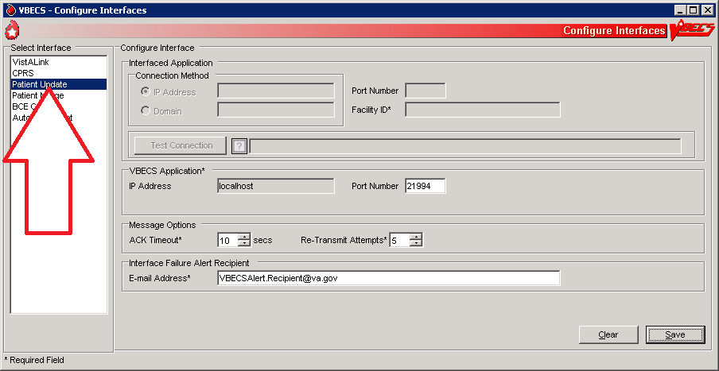

#### Configure Patient Merge HL7 Interface Parameters

| **User Action** | **VBECS Administrator** |
| --- | --- |
| 1. To configure Patient Merge HL7 Interface Parameters, click **File** on the menu of the VBECS Administrator software. | * Displays the menu options used to configure VBECS. |
| 1. Click **Configure Interfaces**. | * Displays the VBECS Configure Interfaces dialog for data entry. |
| 1. To configure Patient Merge HL7 Interface Parameters, select **PatientMerge** from the Select Interface list box in the VBECS – Configure Interfaces dialog (Figure 67). | * Displays the Configure Interfaces group and allows data entry of HL7 interface-related parameters. |
| 1. To configure Interfaced Application group parameters, enter a facility ID in the related data field. | **NOTES**  The IP Address and Port Number fields are disabled: no outbound messages are sent to VistA for this interface.  The facility ID is used in the MSH segment of the HL7 interface to help identify the system. This is a free-text field set to the primary site’s station number. Messaging to VBECS will fail if this Facility ID is not supplied. |
| 1. To configure VBECS Application group parameters, enter a valid port number in the data field. | * Validates that the port number is a whole number from 1024 to 65535.   **NOTES**  The Port Number field represents the VBECS application server port number of the VBECS HL7 Listener. This is typically 21993 for Test and 21994 for Prod. |
| (This step is optional.)   1. To configure Message Options group parameters, enter an ACK Timeout period and number of retransmission attempts in the related data fields. | * Validates that the ACK Timeout period is a whole number from 1 to 999 (seconds) (default: 10). * Validates that the number of retransmission attempts for failed messages is a whole number from 1 to 99 (default: 5). |
| 1. To configure the Interface Failure Alert Recipient group parameter, enter a valid **Administrator distribution** **(Active Directory)** **group** email address in the related data field.   Capture a screen shot. | * Validates the email address is entered correctly.   **NOTES**  Only one email address can be entered which is recommended to contain local Blood Bank users and/or the Blood Bank ADPAC.  VBECS Windows Services will send email alerts to this address when patient merge HL7 messaging errors occur.  Email alerts will not contain PII or PHI.  For assistance troubleshooting the email alerts, see the VBECS Application Interfaces section. |
| 1. Click **Save** and **Yes** to confirm the save. | Changes are saved to the VBECS database and VBECS will attempt to restart the VBECS Prod (or Test) HL7 Listener service if the Port Number has changed.  If the restart fails, you will receive the following message: **The service failed to restart. Please contact VBECS support to have the service restarted**. If you receive the failure message, please file a support ticket (Service Desk Primary Contact). |
| 1. To close the VBECS – Configure Interfaces dialog, click **X** in the upper-right corner. | * Validates that the data was previously saved. |

Figure 67: Example of Configure Interfaces: PatientMerge

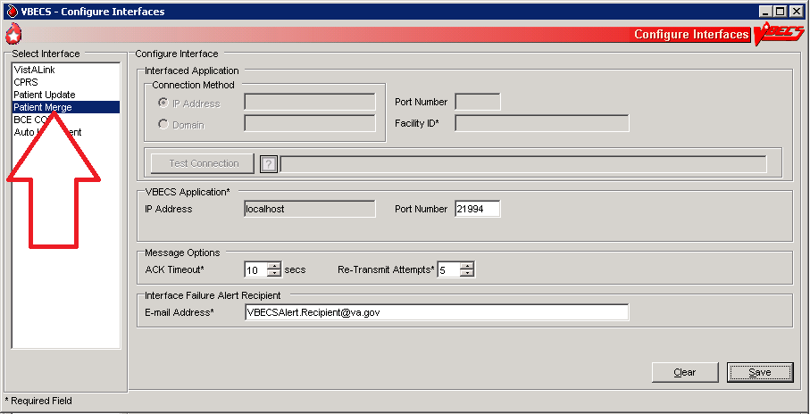

#### Configure BCE COTS Interface Parameters

 Do not configure this interface until the BCE COTS software is available.

| **User Action** | **VBECS Administrator** |
| --- | --- |
| 1. To configure BCE COTS Interface Parameters, click **File** on the menu of the VBECS Administrator software. | * Displays the menu options used to configure VBECS. |
| 1. Click **Configure Interfaces**. | * Displays the VBECS Configure Interfaces dialog for data entry. |
| 1. To configure BCE COTS Interface Parameters, select **BCE COTS** from the Select Interface list box in the VBECS – Configure Interfaces dialog (Figure 68). | * Displays the Configure Interfaces group and allows data entry of BCE COTS interface-related parameters. |
| 1. To configure Interfaced Application group parameters, enter a valid IP address, port number, and facility ID in the related data fields. | * Validates that the IP address is in the standard four-octet notation (e.g., 127.0.0.1) or that the Domain field was filled in. * Validates that the port number is a whole number from 1024 to 65535.   **NOTES**  The IP Address field represents the BCE COTS IP address to which VBECS will direct messages.  The Domain name field represents the fully qualified domain name to which VBECS will direct messages.  The Port Number field represents the BCE COTS port number to which VBECS will direct messages.  The Facility ID is used in the MSH segment of the HL7 interface to help identify the system. This is a free-text field that is usually set to the primary site’s station number. |
| 1. Click **Test Connection**.   Record the IP and port numbers. | **NOTES**  The Test Connection button is enabled only when valid entries exist in the IP Address (or Domain) and Port Number fields. |
| 1. To configure VBECS Application group parameters, enter a valid port number in the data field. | * Validates that the port number is a whole number from 1024 to 65535.   **NOTES**  The Port Number field represents the VBECS application server port number of the VBECS HL7 Listener. This is typically 21993 for Test and 21994 for Prod. |
| (This step is optional.)   1. To configure Message Options group parameters, enter an ACK timeout period and a number of retransmission attempts in the related data fields. | * Validates that the ACK timeout period is a whole number from 1 to 999 (seconds) (default: 10). * Validates that the number of retransmission attempts for failed messages is a whole number from 1 to 99 (default: 5). |
| 1. To configure the Interface Failure Alert Recipient group parameter, enter a valid **Administrator distribution** **(Active Directory)** **group** email address in the related data field.   Capture a screen shot. | * Validates the email address is entered correctly.   **NOTES**  Only one email address can be entered which is recommended to contain local Blood Bank users and/or the Blood Bank ADPAC.  VBECS Windows Services will send email alerts to this address when BCE COTS messaging errors occur.  Email alerts will not contain PII or PHI.  For assistance troubleshooting the email alerts, see the VBECS Application Interfaces section. |
| 1. To enable the BCE COTS interface, the **Interface Disabled** check box must be unchecked. | **NOTES**  The BCE COTS interface is enabled\disabled via this check box. When enabled the fields on the screen become enabled for the BCE COTS interface.  If the BCE interface is disabled through VBECS Admin, no BCE messages will be sent or received from BCE. When the BCE interface is enabled, you will still not send any BCE messages until you stop and start the VBECS Test or Prod Dispatcher service. VBECS will attempt to automatically restart this service if any of the Interfaced Application fields have changed. |
| 1. Click **Save** and **Yes** to confirm the save. | Changes are saved to the VBECS database and VBECS will attempt to restart the VBECS Prod (or Test) HL7 Listener service if the Port Number has changed.  If the restart fails, you will receive the following message: **The service failed to restart. Please contact VBECS support to have the service restarted**. If you receive the failure message, please file a support ticket (Service Desk Primary Contact). |
| 1. To close the VBECS – Configure Interfaces dialog, click X in the upper-right corner. | * Validates that the data was saved. |

Figure 68: Example of Configure Interfaces: BCE COTS

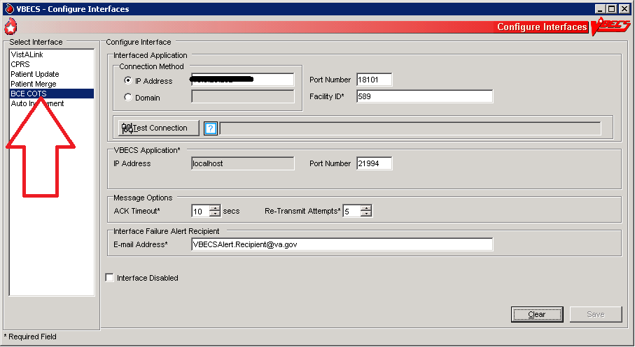

#### Configure Auto Instrument Interface Parameters

 Do not configure this interface unless you use an automated instrument. See VBECS 2.2.0 Automated Instrument and Instrument Manager <instrument> Setup Guide and follow the instructions in the instrument guide.

| **User Action** | **VBECS Administrator** |
| --- | --- |
| 1. To configure Auto Instrument Interface Parameters, click **File** on the menu of the VBECS Administrator software. | * Displays the menu options used to configure VBECS. |
| 1. Click **Configure Interfaces**. | * Displays the VBECS Configure Interfaces dialog for data entry. |
| 1. To configure Auto Instrument Interface Parameters, select **Auto Instrument** from the Select Interface list box in the VBECS – Configure Interfaces dialog (Figure 69). | * Displays the Configure Interfaces group and allows data entry of Automated Instrument interface-related parameters. |
| 1. To configure Interfaced Application group parameters, enter a facility ID in the related data fields. | **NOTES**  The IP Address and Port Number fields are disabled.  The facility ID is used in the MSH segment of the HL7 interface to help identify the system. This is a free-text field set to the primary site’s station number. Messaging to VBECS will fail if this Facility ID is not supplied. |
| 1. To configure VBECS Application group parameters, enter a valid port number in the data field. | * Validates that the port number is a whole number from 1024 to 65535.   **NOTES**  The Port Number field represents the VBECS application server port number of the VBECS HL7 Listener. This is typically 21993 for Test and 21994 for Prod. |
| (This step is optional.)   1. To configure Message Options group parameters, enter an ACK timeout period and a number of retransmission attempts in the related data fields. | * Validates that the ACK timeout period is a whole number from 1 to 999 (seconds) (default: 10). * Validates that the number of retransmission attempts for failed messages is a whole number from 1 to 99 (default: 5). |
| 1. To configure the Interface Failure Alert Recipient group parameter, enter a valid **Administrator distribution** **(Active Directory)** **group** email address in the related data field.   Capture a screen shot. | * Validates the email address is entered correctly.   **NOTES**  Only one email address can be entered which is recommended to contain local Blood Bank users and/or the Blood Bank ADPAC. VBECS Windows Services will send email alerts to this address when Automated Instrument messaging errors occur.  Email alerts will not contain PII or PHI.  For assistance troubleshooting the email alerts, see the VBECS Application Interfaces section. |
| 1. To enable the Auto Instrument interface, the **Interface Disabled** check box must be unchecked. | **NOTES**  The Auto Instrument interface is enabled/disabled via this check box. When enabled, the fields on the screen become enabled for the Automated Instrument interface.  If the Auto Instrument interface is disabled through VBECS Admin, no Auto Instrument messages will be sent or received. |
| 1. Click **Save** and **Yes** to confirm the save. | Changes are saved to the VBECS database and VBECS will attempt to restart the VBECS Prod (or Test) HL7 Listener service if the IP or Port Number has changed.  If the restart fails, you will receive the following message: **The service failed to restart. Please contact VBECS support to have the service restarted**. If you receive the failure message, please file a support ticket (Service Desk Primary Contact). |
| 1. To close the VBECS – Configure Interfaces dialog, click **X** in the upper-right corner. | * Validates that the data was saved. |

Figure 69: Example of Configure Interfaces: Auto Instrument

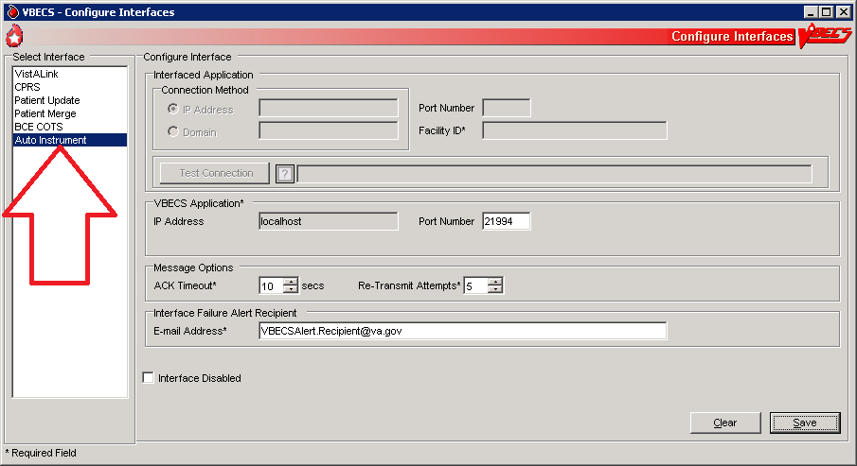

## Configure Divisions MUC_02

The VBECS Administrator configures VBECS as a single division or as multidivisional.

#### Assumptions

The VistA data conversion is complete.

VBECS-VistA connection parameters are set.

VistALink is installed and running on the associated VistA system.

The user is defined in VistA, has a DUZ and connectivity to VistA can be established.

The user has a valid Windows account and is defined as a member of the Active Directory domain group (see **Error! Reference source not found.**).

The IP address of the label printer is known.

The name of the division report printer is known (if multidivisional).

The VBECS database is installed and operational.

User has the VistA secondary menu option VBECS VISTALINK CONTEXT

User has the VistA security key LRBLSUPER and/or LRBLOODBANK

#### Outcome

One or more divisions are defined in VBECS.

One or more divisions are activated as local facilities in VBECS.

#### Limitations and Restrictions

All units in a division must be in a final status and eXM must be disabled to allow the division to change from full-service to transfusion-only or from transfusion-only to full-service.

#### Additional Information

A VBECS Administrator/Supervisor may further configure:

* VBECS users in Update User Roles.
* VBECS division parameters in Configure Division, Product Modifications, and Configure Testing.

The user must log onto VistA.

#### User Roles with Access to This Option

VBECS Administrator

#### Add and Maintain DivisionsTechDoc Task 1103

The user defines and maintains division attributes.

 Changes made in the VBECS Administrator option mapping orders to another VBECS division do not affect delivered orders. Orders delivered to a VBECS division must be completed, rejected, or canceled in that division. Resubmit orders after mapping is completed to send an order to another VBECS division.

| **User Action** | **VBECS Administrator** |
| --- | --- |
| 1. To add and maintain divisions in VBECS, click **File** on the main menu of the VBECS Administrator software. | * Displays the menu options used to configure VBECS. |
| 1. Select **Configure Divisions** (Figure 70). | * Displays the Configure Division dialog and allows entry of division parameters. |
| 1. To edit a defined division, click the **Division Identification** tab (Figure 71). Select a division code or name from the drop-down menu or, to configure a new division, click the **ellipsis** button. Select a division from the list (Figure 72). | **NOTES**  MBR_2.05 The user may not edit the division code or name.  BR_9.01, BR_9.02, BR_9.09 A division may be full-service (default) or transfusion-only. When a unit not in a final status exists, a user may not change the type of transfusion service.  When a division is transfusion-only, VBECS disables electronic crossmatch.  When a division changes from full-service to transfusion-only, units already in inventory are not restricted to patients and must be returned to the blood center.  When a division changes from transfusion-only to full-service, inventory units are restricted to patients without ABO/Rh confirmation. The facility must decide how to handle this existing inventory.  VBECS prevents the user from changing a division from full-service to transfusion-only or from transfusion-only to full-service when there are open or partially completed worksheets or processes in the division.  TechDoc Task 812The Division Name and Division Code are identified in the VistA INSTITUTION file (#4). The Division Name stored in VBECS is the INSTITUTION file NAME field (#.01); the Division Code stored in VBECS is the STATION NUMBER field (#99). When either value change in VistA, rerun these steps to update the VBECS database with the current values from VistA. |
| 1. To receive orders from VistA Institutions to the selected Division, check the Map orders from VistA institutions check box. Click the Active checkbox for each institution that applies. | **NOTES**  Changes made to institution mappings require a restart of the VBECS HL7 Listener service. For more information, see Table 9 in the VBECS Windows Services section. DR 2984  MBR_2.32 One or more VistA institutions from the list of valid institutions retrieved from VistA may be associated with the selected VBECS division from the list of valid institutions retrieved from VistA.  MBR_2.29 A VistA institution may be associated with only one VBECS division.  MBR_2.30A VistA institution defined as a VBECS division is not eligible for selection as an associated institution to a different VBECS division.  MBR_2.04 To associate additional institutions, enable an optional VistALink query to retrieve a list of all institutions associated with the VistA site that are currently defined within the VistA database but not in the selected VBECS division. VBECS displays the list to the user for selection. |
| 1. Select the FDA Registered Facility associated with the division or, to search for the facility by name or FDA Registration Number, click the **ellipsis** button (Figure 71). | * Allows the user to associate a division with a facility from the National Facility Table.   **NOTES**  MBR_2.14 The user must associate a division with a facility from the National Facility Table. If there is no matching facility, VBECS Administrator asks the user to contact the Service Desk Primary Contact.  When this occurs, wait for customer support to respond or, to continue establishing a division, select and configure any facility from the National Facility Table. When the configuration is complete, use the Local Facilities option in VBECS to define the local facility that matches the information missing from the National Facility Table.  Return to Configure Divisions to re-associate your division with the newly entered local facility.  BR_17.05 When a division is configured, VBECS displays, “I certify that the blood products listed were properly maintained, in accordance with the Code of Federal Regulations, while in storage at this institution. Components were inspected when packed for shipment and found to be satisfactory in color and appearance.” |
| 1. Select the VistA Lab Blood Bank Accession Area associated with the selected division from the drop-down menu (Figure 71). | **NOTES**  The Lab package uses the Accession Area to track blood bank- related workload for the division. New VA hospitals that require enabling a blood bank must activate and assign a division to an accession area. |
| 1. Enter the desired number of minutes in the Lock Inactivity Timeout field. | * Allows the user to set the lock inactivity timeout period [5 to 15 minutes (default: 5 minutes)].   **NOTES**  MBR_2.13The lock inactivity timeout period specifies how long a user can be idle and in control of data being edited. VBECS warns the user 60 seconds before the lock inactivity period expires that he will lose priority for the data. When he responds within 60 seconds, VBECS clears the warning and resets the lock activity timer. Otherwise, VBECS informs him that his lock was released and he must reenter his changes.  VBECS uses optimistic and pessimistic locking to prevent data corruption. If a user attempts to edit data locked by another user, VBECS alerts him that the record is in use and prevents access (pessimistic locking).  If more than one user attempts to change data simultaneously, VBECS accepts only the first update and warns the other users that the record changed (optimistic locking, which is non-configurable and a fail-safe to pessimistic locking). |
| 1. To activate or inactivate the division, click or clear the **Active VBECS Division?** check box (Figure 71).   Capture a screen shot. | * MBR_2.11 When the user saves a previously active division as inactive, inactivates user roles for that division.   **NOTES**  The system will not allow the user to activate a division that has orders mapped to another VBECS division. VBECS displays, “Unable to activate. The VBECS division currently has orders mapped to another VBECS division.”  The system will not allow the user to inactivate a division that has orders mapped to it. VBECS displays, “Unable to inactivate. This VBECS division currently has orders mapped to it. Release this mapping prior to inactivation,” |
| 1. Click the **Service Type** tab. Click the **Full-Service Facility** or **Transfusion-Only Facility** radio button (Figure 74).   Capture a screen shot. | * Allows the user to identify the facility as full-service or transfusion-only.   **NOTES**  **image001** When the division changes from full-service to transfusion-only or from transfusion-only to full-service, information must be in a final state. VBECS does not check for pending orders or active units in inventory, so there is a risk of corrupting information. There is a risk of having unconfirmed units available for transfusion if any are issued. |
| 1. Click the **Printers** tab.   Select a Default Report Printer from the list.  Clear or click the **Division Uses Label Printer** check box.  Edit the port number and/or the TCP port number.  Enter the IP address (Figure 75).  Capture a screen shot. | * MBR_2.24Allows the user to enter the TCP port number and the IP address for the label printer. * MBR_2.31Allows the user to select the default printer for the division when more than one printer is installed on the system.   **NOTES**  Standard values for TCP port:  TCP = 9100 |
| 1. Click the **Time Zone tab**.   Select a time zone.  In the Daylight Savings field, select **US Standard DST**, **Do not observe DST**.  Capture a screen shot. | * Allows the user to set the time zone and daylight saving parameters. |
| 1. Click **Save** and **OK** to commit the changes or add the new division to the VBECS database. | * Commits changes and additions to the database.   **NOTES**  Multidivisional sites must repeat Steps 3 through 11 for each division.  DR 2,717The VBECS Administrator/Supervisor who configured the divisions must add himself as a user to all divisions to enable the functionality of canned comments in the VBECS system. |
| 1. To close the **VBECS** – **Configure** **Divisions** dialog, click  in the upper-right corner. |  |

Figure 70: Example of Configure Divisions

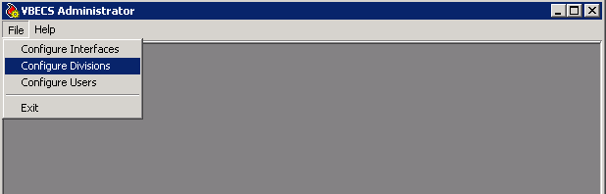

Figure 71: Example of Configure Division: Division Identification

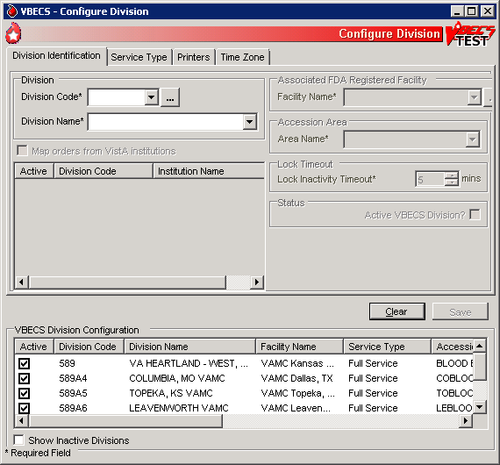

Figure 72: Example of Select VistA Divisions

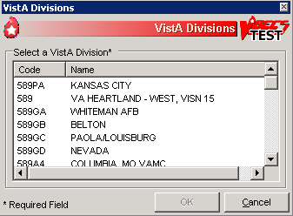

Figure 73: Example of Facility Search

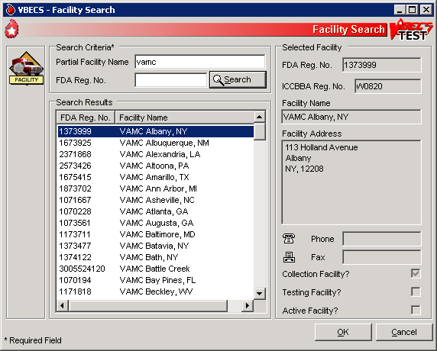

Figure 74: Example of Configure Division: Service Type

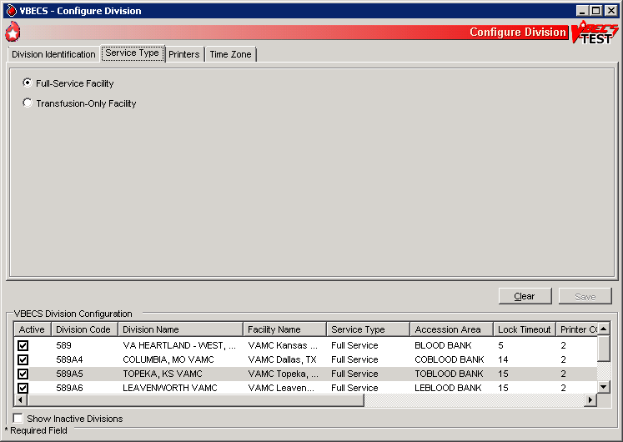

Figure 75: Example of Configure Division: Label Printing

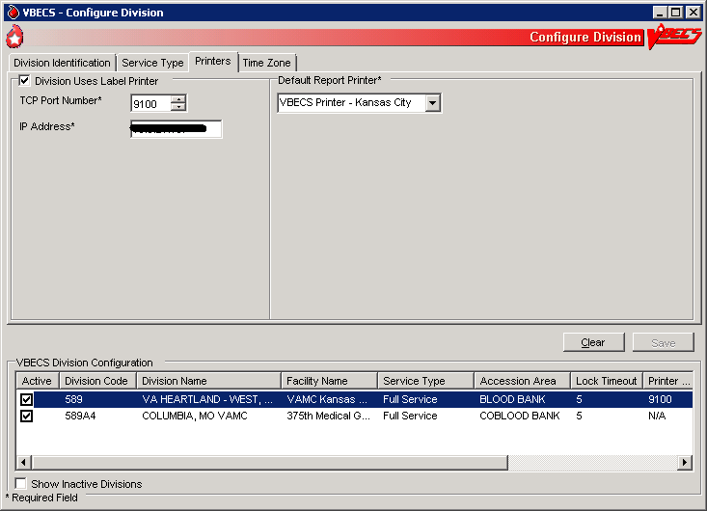

## Configure Users MUC_03

The VBECS Administrator matches VistA users to VBECS users and sets user security levels.

#### Assumptions

The VistA data conversion is complete.

All VBECS users must have the LRBLSUPER and/or LRBLOODBANK security key.

VBECS-VistA connection parameters are set.

VistALink is installed and running on the associated VistA system.

VBECS application configuration files have the correct values for Domain and user group fields.

At least one division in VBECS is configured.

The user is defined in VistA, has a DUZ and connectivity to VistA can be established.

All users of the blood bank medical device software are assigned the VBECS VISTALINK CONTEXT option as a secondary option. VistALink uses the VBECS VISTALINK CONTEXT option to provide user context sign-on security to VistA.

The user has a valid Windows login and is defined as a member of the Active Directory domain group.

The System Administrator created Active Directory local groups, as directed in Appendix D: Blood Bank Configuration Checklist, Create Local Groups, in *VistA Blood Establishment Computer Software (VBECS) Installation Guide*.

The VBECS database is installed and operational.

The user must be assigned/belong to an active division in VistA. DR 4958

The user must have logged into the VistA account successfully at least once. DR 4958

The user has the XOBV VistALink Tester as a secondary menu (to test the VistALink connection in VBECS Administrator). DR 4958

The user’s record in VistA File #200 – New Person File, must not have a Termination Date and the DISUSER flag must not be set. DR 4958

#### Outcome

VBECS users are defined and able to use VBECS.

#### Limitations and Restrictions

 Each VBECS user must have a unique Windows login ID. If a Windows login ID becomes inactive and is eligible for re-use in Active Directory, do not re-use it for VBECS: it may result in corrupted data in VBECS.

A user must not change their Windows login ID after being configured in VBECS. If the user’s name changes, the name fields in Active Directory can be modified without changing the login ID. (DR3470)

#### Additional Information

A VBECS Administrator/Supervisor may further configure VBECS users in Update User Roles.

The user must log onto VistA.

#### User Roles with Access to This Option

VBECS Administrator

#### Configure VBECS Users

Active Directory groups must be setup prior to configuring users in VBECS. Contact a local system administrator to add or remove VBECS users from your VBECS Active Directory groups.

| **User Action** | **VBECS Administrator** |
| --- | --- |
| 1. To add and maintain users in VBECS, click **File** on the main menu of the VBECS Administrator software. | * Displays the menu options used to configure VBECS. |
| 1. Select **Configure Users** (Figure 76). | * Allows the user to enter or edit user information. |
| 1. To edit an existing user, select a user ID from the drop-down list (Figure 77) or, to search for a new user ID to add to VBECS, click the **ellipsis** button to the right of the drop-down list (Figure 78).   Enter user parameters.  MBR_3.07 For each user, VBECS stores:   * VistA DUZ * Windows Login ID * Windows Username * Email Address (optional) * User Initials * Active Status * Division Code * User Role * Division Active Status | * Displays the Windows user ID and name.   **NOTES**  MBR_3.11 VistALink lists active VistA Blood Bank users. VistA Blood Bank users are identified by the LRBLOODBANK and LRBLSUPER security keys.  MBR_3.10 When VBECS finds users that are inactive in VistA, it asks whether the user wishes to inactivate them in VBECS. **Yes** inactivates the VBECS users. **No** allows the user to continue without inactivating the users (Figure 81).  MBR_3.01, MBR_3.03, and MBR_2.05 The user may not edit the VistA DUZ or user name, the Windows login ID or user name, or the division code or name.  MBR_3.02 There is a one-to-one correspondence between Windows and VistA users. A VistA DUZ may be associated with only one Windows login ID and vice versa.  MBR_3.04 and BR_19.07 The user may:  Activate or inactivate but not delete a defined user from VBECS.  Rescind a defined user’s access privileges at one or more divisions but not delete his record or ID from the database.  The user ID stored in VBECS BR_19.04 is the user’s Windows Logon ID.  BR_2.18 VBECS displays the data that a user enters in a session. The user may edit and save the data. When a user cancels, VBECS warns that it will not save the data. VBECS closes the form and returns the user to the main menu screen that may include unrelated open windows.  BR_2.13 VBECS associates the technologist ID, date, time, and division with each process for retrieval by division. |
| 1. To search for a VistA user, click the **ellipsis** button to the right of the VistA DUZ field (Figure 79). | * Allows the user to search for VistA Blood Bank users by name or DUZ.   **NOTES**  The user may not edit the VistA DUZ or user name, the Windows login ID or user name, or the division code or name. |
| 1. Enter the email address of the user in the E-mail field in the Additional Info group. VistA provides the initials, if available. If not, enter them. | * Allows the user to enter Additional Information about the user for identification.   **NOTES**  MBR_3.08 and MBR_3.09 User initials may be loaded from VistA. VBECS requires unique user initials for use as the technologist ID. |
| 1. To select a VistA division to associate with the user, click the **ellipsis** button to the right of the Division Code drop-down menu (Figure 80). | * Allows the user to select a division to associate with the user   **NOTES**  BR_19.02 A single user may be associated with multiple divisions. |
| 1. Select a user role from the User Role drop-down menu. Click or clear the **Active Role?** check box to activate or inactivate the role. | * Allows the user to assign security roles to the blood bank user. * If a user was removed from the role of Administrator/Supervisor and was the only Administrator/Supervisor user left for a division, displays “You are trying to remove the last Administrator/Supervisor for your division, which would disallow system configuration in the future. You may not proceed.” If all entered data is satisfactory, saves user details and access changes to the file and adds or updates the user information in the list view.   **NOTES**  BR_19.03 and MBR_3.06 One role at a time may be assigned to a user at a division. A user may have only one active user role per division.  BR_19.05 VBECS allows the assignment of a security level to one or more users at a time.  BR_19.06 VBECS warns that there must be at least one level 6 VBECS Administrator/Supervisor in the division and does not allow the user to change the last Administrator/Supervisor. |
| 1. Click **Update** and **Save**. | * Displays a confirmation dialog. |
| 1. Click **Yes** to commit changes to the database. | * Click **Yes** to commit changes to the database. |
| 1. To close the Edit Users dialog box, click  in the upper-right corner. |  |

Figure 76: Example of Configure Users

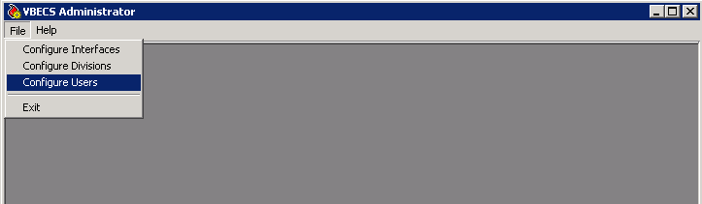

Figure 77: Example of Edit User

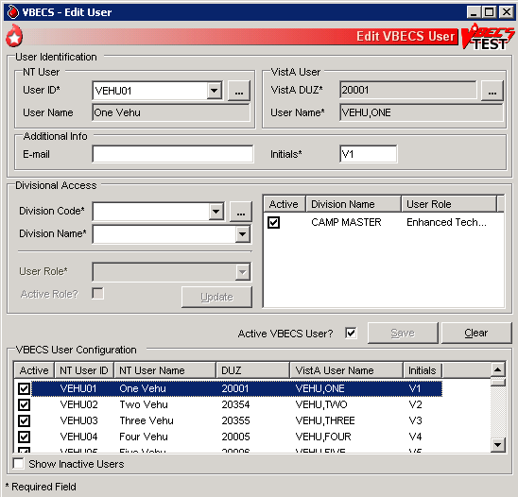

Figure 78: Example of Windows Users

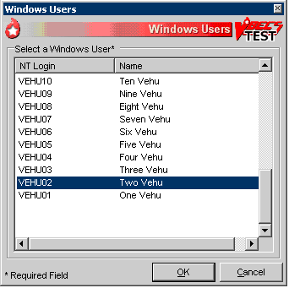

Figure 79: Example of VistA Users

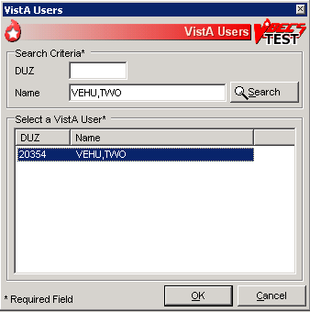

Figure 80: Example of VistA Divisions

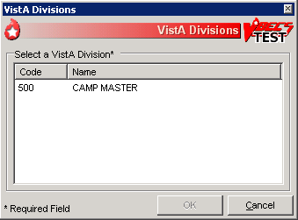

Figure 81: Example of Inactive Users

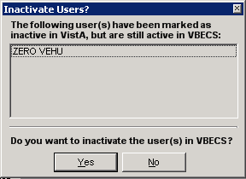

## Record Workload DataUC_15

VBECS workload data is recorded in VBECS when records that qualify as Workload Events are saved in VBECS. This data is transmitted to the VistA Laboratory workload recording system for national and local workload reporting.

#### Assumptions

Workload codes were assigned to VBECS processes using Workload Codes.

Healthcare Common Procedure Coding System (HCPCS) codes were assigned to blood products using Blood Products.

A record was saved or inactivated immediately preceding workload data collection.

The connection to VistA is active.

#### Outcome

Information was transmitted to VistA for inclusion in appropriate reports.

#### Limitations and Restrictions

None

#### Additional Information

Workload Event data must include information required for Decision Support System (DSS), Patient Care Encounter (PCE), and Billing Awareness. Once in VistA, existing VistA functionality will handle required reporting.

Billing Awareness is being developed concurrently and related requirements are anticipated based on initial contact with the Billing Awareness team.

The system accumulates and periodically transmits workload information to the VistA Lab workload recording process. The data is transmitted from VBECS to VistA by the VBECS Workload Capture Remote Procedure called by a nightly Lab background process.

Workload multipliers for all blood bank activities in VistA File #64 must be set to one (1) to avoid excessive Laboratory Management Index Program (LMIP) counts. This allows the workload multiplier set in VBECS to be correctly reflected on VistA reports.

#### User Roles with Access to This Option

All users

#### Transmit Workload Data

These steps are associated with the “Save” function within any class that performs a Workload Event such as recording a blood test result or interpretation for a unit or a patient, modifying a unit, and pooling units. VBECS must know which classes perform Workload Events and how to classify the work accomplished for reporting. When the database is updated, the VistA technologist ID of the updater, the division, and the date and time of the update are recorded. In some instances, a mechanism to capture LMIP workload information exists. In addition, for certain eventsthat involve patient processing, the patient location, treating specialty, service, etc., are captured to satisfy PCE or DSS reporting requirements.

These steps address the initial recording of these events.

| **User Action** | **VBECS** |
| --- | --- |
| 1. Click **Save** to save a record from an option. | * CBR_15.01 Creates a Workload Event for every process record saved. * Recognizes the activity as a new Workload Event. * Checks for required reporting properties based on the type of record being saved. * Determines the proper workload codes and other related information to be included.   **NOTES**  One or more workload codes can be collected with each Workload Event saved. A workload code may be multiplied for certain Workload Events. |
| 1. Exit. |  |

#### Inactivate a Workload Event

VBECS updates VistA to inactivate the associated workload information (for a patient or a unit) so that PCE and Billing Awareness can be updated to reflect that the transaction is not valid.

|  |  |
| --- | --- |
| **User Action** | **VBECS** |
| 1. Inactivate a saved record. | * Recognizes the activity performed as an inactivation of an existing Workload Event record.   **NOTES** |
| 1. Complete the update and choose to save. | * Prompts to confirm the save. Saves workload data.   **NOTES**  When a previously saved workload-generating event is invalidated (such as in Remove Final Status, Invalidate Test Results, or invalidating previously logged-in units through Edit Unit Information or Invalidate Shipment), VBECS must create and transmit the same Workload Event information to VistA as a negative number. |
| 1. Confirm the save. | * Saves workload data.   **NOTES**  When a saved Workload Event is associated with a patient, VBECS needs to link the Workload Event to the patient for future reports. |
| 1. The option ends when the record is saved. |  |

External Interfaces

## VistALink Remote Procedure Calls

Remote Procedure Calls (RPCs) provide a method of data exchange through VistALink for VBECS. The VBECS software provides data to or receives data from the VBECS Application Interfacing Support Software (VAISS) located in the VistA M environment through RPCs. This data exchange is controlled through Database Integration Agreements (DBIAs) between the blood bank medical device software and the VAISS VistA M software.

The VAISS software provides a set of M Application Programmer Interfaces (APIs) that call VBECS RPCs through the VBECS VistALink Listener Windows Service and return blood bank data to other VistA applications. The VAISS software also provides a set of VistA RPCs under the VBECS namespace in the Remote Procedure File (#8994) that are called by the VistA VistALink Listener client-server software. These calls are not public utilities and may be subject to change.

Table 8: Remote Procedure Calls

| **RPC Name** | **Database Integration**  **Agreement (DBIA)** | **This RPC:** |
| --- | --- | --- |
| VBECS Order Entry | 4619 | Supports order entry of blood bank requests from the blood bank order entry dialog in CPRS |
| VBECS Patient Available Units | 4620 | Provides a list of assigned, crossmatched, autologous and directed blood units that are available for a patient |
| VBECS Patient Transfusion History | 4621 | Provides a list of past transfusions performed for a patient |
| VBECS Blood Products | 4622 | Provides a list of orderable blood products, or component classes, to the VistA Surgery package |
| VBECS Patient Report | 4623 | Provides patient specimen testing results, component requests, and available blood units for a patient to be displayed in CPRS |
| VBECS Patient ABO_RH | 4624 | Provides the most current ABO Group and Rh Type identified for a patient |
| VBECS Patient ABID | 4625 | Provides a list of antibodies identified for a patient |
| VBECS Patient TRRX | 4626 | Provides a list of transfusion reactions for a patient |
| VBECS Workload Capture | 4627 | Provides blood bank workload data to the VistA Laboratory Service package for workload reporting to national and local entities |
| VBECS Workload Update Event | 4628 | Inserts completed workload-related data into the VBECS database after the VistA Laboratory Services package has completed workload-reporting transactions. Upon completion of the insert, the RPC returns an XML response to the VAISS that initiated the communication indicating a successful or unsuccessful transaction. |
| VBECS Accession Area Lookup | 4607 | Provides a list of all Laboratory Blood Bank Accession Areas in VistA and their associated divisions to VBECS for workload reporting purposes |
| VBECS Blood Bank User Lookup | 4608 | Returns a list of all blood bank users identified in the VistA system to VBECS. Blood bank users are identified by the Security Keys of either LRBLOODBANK or LRBLSUPER. |
| VBECS Division Lookup | 4609 | Returns a list of all VAMC divisions associated with a VistA system |
| VBECS HCPCS Codes Lookup | 4610 | Returns a list of blood bank related HCPCS codes to be associated with processes, or procedures, performed in VBECS |
| VBECS Laboratory Test Lookup | 4611 | Returns a list of VistA Laboratory tests to be associated with blood components in VBECS |
| VBECS Lab Test Results Lookup | 4612 | Returns a list of VistA Laboratory test results for a patient |
| VBECS Medication Profile Lookup | 4613 | Returns a list of medications for a patient from the VistA Pharmacy package |
| VBECS Lab Accession UID Lookup | 4614 | Returns data from the VistA Laboratory Services package based on a Lab order number. The data is used to validate a VBECS specimen test request for a patient and specimen received in the blood bank for that test. |
| VBECS Workload Codes Lookup | 4615 | Returns a list of blood bank related workload related data that is associated with processes in VBECS |
| VBECS Patient Lookup | 4616 | Provides a patient lookup function using standard VistA patient lookup criteria. A list of matching patients found in the lookup is returned to VBECS along with required patient identifiers and demographics. |
| VBECS Provider Lookup | 4617 | Provides a lookup of VistA users that hold the PROVIDER security key |
| VBECS Hospital Location Lookup | 4618 | Returns a list of hospital locations associated with a division in VistA |
| VBECS Lab Order Lookup by UID | 4633 | Returns a list of Laboratory Services data related to an order based on a specimen UID |
| VBECS Dss Extract | 4956 | Provides BloodBank post-transfusion related data to the VistA DSS Blood Bank Extract application for DSS reporting |
| TCPConnect | N/A | The purpose of this RPC is to establish a Broker TCP IP connection. This RPC initiates the initial connection between VBECS and the Broker. This is not yet using the token; this is an initial connection to the required Broker endpoint. |
| XUS SIGNON SETUP | N/A | The purpose of this RPC is to authenticate user with a Client Agent token during each application’s session. This is the IAM Sign on and Setup steps needed prior to validation. |
| XUS ESSO VALIDATE | N/A | The purpose of this RPC is to validate a user's token for each session. This is the IAM token validation that occurs inside VistA. |
| XUS GET TOKEN | N/A | The purpose of this RPC is to return a handle to a token that will sign-on a new process for subsequent RPC calls. |

## VBECS Windows Services

 Changes made to individual HL7 listeners must be validated in the test account before using in production.

VBECS uses Microsoft Windows Services (services) to provide minimal downtime and minimal user interaction. These services are installed on each VBECS application server. For details on stopping and starting VBECS services, see the Stopping VBECS Services and Starting VBECS Services sections. All VBECS services start with the VBECS namespace prefix. There are duplicate services for production and test accounts that provide functionality for their respective databases. See Figure 82 for a complete listing of VBECS services.

Figure 82: Example of VBECS Services

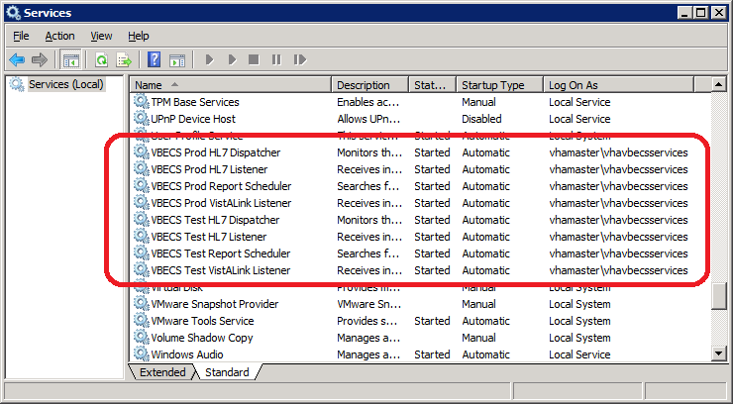

Table 9: VBECS Windows Services

| **Windows Service Name** | **Description** |
| --- | --- |
| VBECS Prod HL7 Dispatcher | The startup type is set to automatic. It polls the VBECS Production database for HL7 messages to be sent to CPRS or BCE in the VistA Production account. |
| VBECS Prod HL7 Listener | The startup type is set to automatic. This is the default HL7 listener service for all Production HL7 interfaces |
| VBECS Prod Report Scheduler | The startup type is set to automatic. It runs scheduled VBECS reports for the Production database. |
| VBECS Prod VistALink Listener | The startup type is set to automatic. It provides a client-server TCP/IP listener service for VistALink RPC XML messages from the VAISS APIs. It calls VBECS RPCs to provide blood bank data from the VBECS Production database to VistA Production account applications. |
| VBECS Test HL7 Dispatcher | The startup type is set to automatic. It polls the VBECS Test database for HL7 messages to be sent to CPRS or BCE in the VistA Test account. |
| VBECS Test HL7 Listener | The startup type is set to automatic. This is the default HL7 listener service for all Test HL7 interfaces. |
| VBECS Test Report Scheduler | The startup type is set to automatic. It runs scheduled VBECS reports for the Test database. |
| VBECS Test VistALink Listener | The startup type is set to automatic. It provides a client-server TCP/IP listener service for VistALink RPC XML messages from the VAISS APIs. It calls VBECS RPCs to provide blood bank data from the VBECS Test database to VistA Test account applications. |

This page intentionally left blank.

# Troubleshooting

Remote Desktop Session IssuesDR 4373

Occasionally remote desktop sessions require disconnection by a server administrator. Sessions may become unresponsive and require disconnection. Additionally if you need to apply a patch such as a window update but sessions remain on the server you may need to force a session to disconnect. To disconnect a remote session navigate to the application or SQL server and click Start, Administrative Tools, Remote Desktop Services, Remote Desktop Services Manager. Locate the session(s) that require disconnection. Right-click on the session and select Disconnect (Figure 83).

Figure 83: Example of Remote Desktop Services Manager

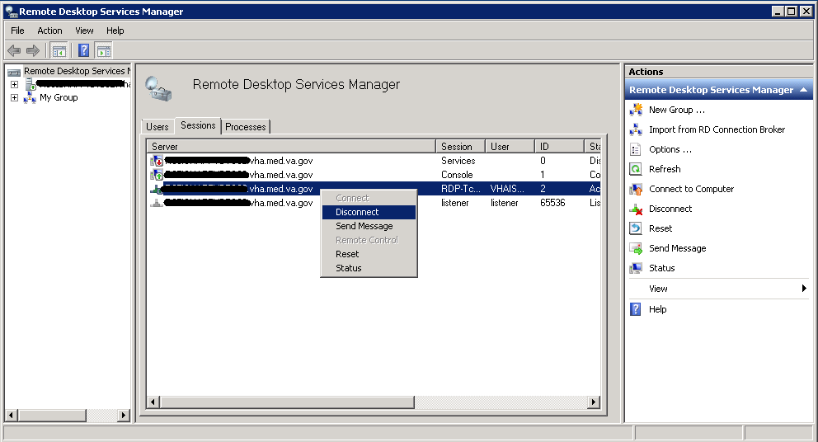

Remote Desktop Services Licensing Issues DR 4373

In order to connect to VBECS, a workstation must have a valid license from an active Remote Desktop Services licensing server. A problem may occur when this license has expired on the workstation; the user receives an error message when trying to establish a Remote Desktop Connection (Figure 84). Deleting the Remote Desktop Services license information from the registry will cause the workstation to refresh its license information and restore the ability to connect using remote desktop.

Figure 84: Example of Expired Remote Desktop License

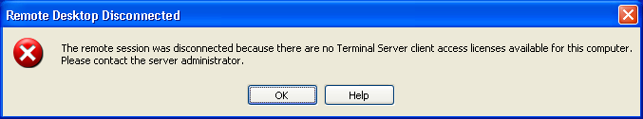

#### Deleting the Remote Desktop Services Licensing Information on a VBECS Workstation

Administrative rights on the workstation are required to perform the following steps.

1. Log into the workstation that is receiving the error (Figure 84) and click **Start, Run…**
2. In the Run window, type **regedit** and click **Enter**.
3. In the Registry Editor window, expand the folders to the following location: **Computer, HKEY_LOCAL_MACHINE, SOFTWARE, Microsoft**.
4. Locate and right-click the **MSLicensing** folder; select **Delete** (Figure 85).

Figure 85: Deleting the MSLicensing Registry Key

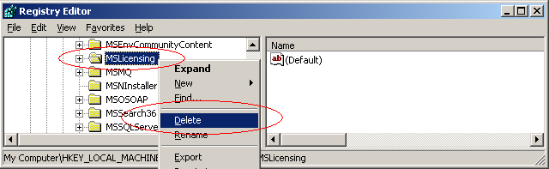

1. Make sure you are at the correct path and click **Yes** to confirm the deletion.
2. Close the Registry Editor.

#### Identity Verification Warning

Occasionally, a warning may appear when initiating an RDP session that states that the identity of the remote computer could not authenticated (Figure 86). This is due to an archived certificate and is not dangerous. Select **Don’t ask me again**… and click **Yes**.

Figure 86: Example of Identity Warning

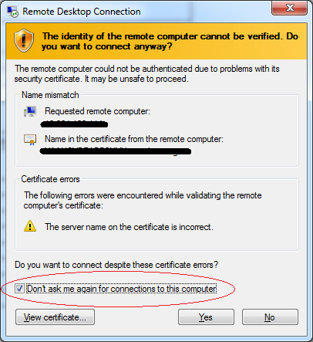

Stopping and Starting VBECS Services

#### Stopping VBECS Services

1. Click **Start, Administrative Tools, Services** (Figure 87).
2. Right-click on the service you would like to stop and click **Stop**.

Figure 87: Example of Stopping a VBECS Service

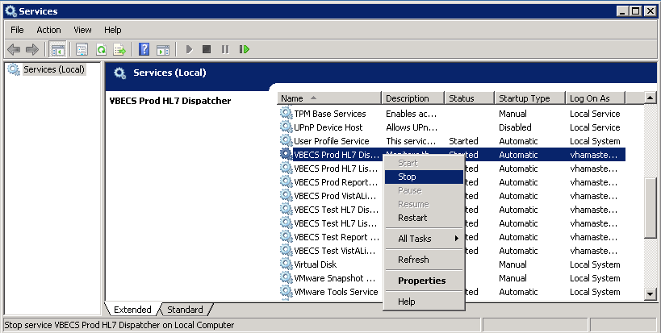

#### Starting VBECS Services

1. Click **Start, Administrative Tools, Services** (Figure 88).
2. Right-click on the service you would like to start and click **Start**

Figure 88: Example of Starting a VBECS Service

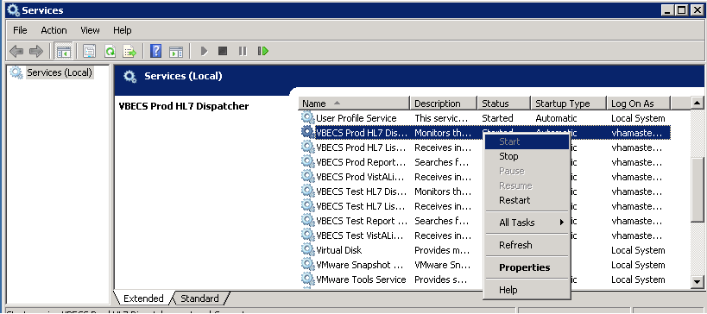

### VBECS AuditingTechDoc Task 628

For a complete list of audited server events, please see: Appendix C: Auditing on VBECS Servers.

### VBECS Exception LoggingTechDoc Task 628

VBECS logs all errors that occur in the system in the Application log of Event Viewer on the application server. A user defined as an administrator on the application server can connect to the server through Remote Desktop Connection to view these errors.

* Click **Start**, **Control Panel, Administrative Tools**.
* Open the Event Viewer and open the Windows logs folder, then select Application to view the errors that VBECS logs.
* In the list view on the right side of the screen, click the date column header to sort the errors by date.
* Evaluate “Error” and warning errors that were logged at the same time a VBECS user reported an error. Ignore informational messages. If you require assistance from the VBECS maintenance and maintenance team, file a support ticket (Service Desk Primary Contact).

### VBECS Application Interfaces

When the HL7 Listener service encounters an error parsing an HL7 message it generates an event description like the following:

VBECS Patient Update HL7 Parser: Error processing HL7 message:

Missing or invalid content in HL7 message:

ERR^MSH~1~12~203~

Upon troubleshooting an email message regarding an HL7 message, file a ticket with the Service Desk Primary Contact and include the contents of the email for a description so that Health Product Support can assist in identifying the patient associated with the failed HL7 message. Due to PII and HIPAA constraints, patient information will not be sent over email. Product support will have access to the event viewer and be able to identify the appropriate patient information. Table 10 describes the ERR codes (e.g., 203 like in the above example) descriptions.

Table 10: Troubleshooting Rejected VBECS HL7 Messages

| **Error Code** | **Description of Problem** |
| --- | --- |
| 100 | Segment Sequence Error |
| 101 | Required Field Missing |
| 102 | Data Type Error |
| 103 | Table Value Not Found |
| 200 | Unsupported Message Type |
| 201 | Unsupported Event Code |
| 202 | Unsupported Processing ID |
| 203 | Unsupported Version Id  See Table 11: VBECS HL7 Versions. |
| 204 | Unknown Key Identifier |
| 205 | Duplicate Key Identifier |
| 206 | Application Record Locked |
| 207 | Application Internal Error |
| 208 | Conflicting Processing Id |

Table 11: VBECS HL7 Versions

|  |  |
| --- | --- |
| **HL7 Interface** | **HL7 Version** |
| VistA CPRS- Order Update – CPRS OERR | 2.4 |
| VistA PIMS Patient ADT Update – VAFC ADT | 2.3 |
| VistA MPI/PD PatientMerge – MPI TRIGGER | 2.4 |
| BCE COTS – Patient Blood Product Transfusion Verification | 2.5 |
| Automated Instrument | 2.4 |

Table 12: Troubleshooting VBECS Application Interfaces

| **Source** | **Description of Problem** | **Possible Cause** | **Solution** |
| --- | --- | --- | --- |
| VBECS: Order Alerts and Pending Order List | New orders or cancellations of existing orders in CPRS are not showing up in VBECS. | The OERR-VBECS Logical Link is not running on the VistA system. | Start the OERR-VBECS Logical Link. |
| The VBECS <Prod or Test> HL7 Listener Windows Service is not running or is locked on the application server. | Start or restart the VBECS <Prod or Test> HL7 Listener Windows Service. |
| Network connectivity issue | Contact local system support. |
| The HL7 message is missing patient last or first name or one or more name components length(s) exceed(s) the VBECS maximum supported value. | VBECS responds to the new order request with an application reject (AR) acknowledgement message indicating Patient Name(s) not found in HL7 Message or Patient's Name(s) field size(s) exceed(s) VBECS maximum supported value. Rejected patient order messages due to invalid patient name message content are recorded on the Windows Event Log (Finding Application Log Entries from Email Alerts) and an email message containing the MSH segment of the rejected HL7 message. |
| VBECS Admin: Configure Division | New orders are not showing up in VBECS. | Order mappings to institutions within a division’s configuration were changed. | Stop and restart the VBECS <Prod or Test> HL7 Listener Service. |
| VBECS: Patient Update Alerts | VistA patient updates are not showing up in VBECS. | The patient being updated in VistA is not in the VBECS Patient table and is, therefore, not a blood bank patient. | No action is required. |
| The fields that were updated in VistA are not stored in VBECS; therefore, no data will be updated. | No action is required. |
| The Taskman scheduled option VAFC BATCH UPDATE is not scheduled to run or has not reached the time limit in the schedule. | Schedule the VAFC BATCH UPDATE option to run at the desired frequency (the recommended frequency is every 10 minutes) or use the option “One-time Option Queue” in the Taskman Management Options to start the task. |
| The VBECSPTU Logical Link is not running on the VistA system. | Start the VBECSPTU Logical Link. |
| The VBECS <Prod or Test> HL7 Listener Windows Service is not running or is locked on the application server. | Start or restart the VBECS <Prod or Test> HL7 Listener Windows Service. |
| Network connectivity issue | Contact local system support. |
| The HL7 message is missing patient last or first name or one or more name components length(s) exceed(s) the VBECS maximum supported value. | VBECS responds to the patient update request with an application reject (AR) acknowledgement message indicating Patient Name(s) not found in HL7 Message or Patient's Name(s) field size(s) exceed(s) VBECS maximum supported value. Rejected patient update messages due to invalid patient name message content are recorded on the Windows Event Log (Finding Application Log Entries from Email Alerts) and an email message containing the MSH segment of the rejected HL7 message as a means to identify the message in the server event log is sent to the interface failure alert recipient set in VBECS Administrator for immediate action. |
| VBECS: Patient Merge Alerts | VistA Patient Merge events are not showing up in VBECS. | The two patient identifiers in the merge do not exist in VBECS and, therefore, cannot be merged. | No action is required. |
| The VBECPTM Logical Link is not running on the VistA system. | Start the VBECSPTM Logical Link. |
| The VBECS <Prod or Test> HL7 Listener Windows Service is not running or is locked on the application server. | Start or restart the VBECS <Prod or Test> HL7 Listener Windows Service. |
| Network connectivity issue | Contact local system support. |
| The HL7 message is missing patient last or first name or one or more name components length(s) exceed(s) the VBECS maximum supported value. | Failed patient merge messages due to invalid patient name message content are recorded on the Windows Event Log and an email message containing the MSH segment of the rejected HL7 message as a means to identify the message in the server event log is sent to the interface failure alert recipient set in VBECS Administrator for immediate action. |
| VistA: HL7 System Link Monitor | The VistA HL7 System Link Monitor shows more MESSAGES TO SEND than MESSAGES SENT for the OERR-VBECS Logical Link and is hung in an “Open” state. | The VBECS <Prod or Test> HL7 Listener Windows Service is not running or is locked on the VBECS Application server. | Start or restart the VBECS <Prod or Test> HL7 Listener Windows Service. |
| Network connectivity issue | Contact local system support. |
| The VistA HL7 System Link Monitor shows more MESSAGES TO SEND than MESSAGES SENT for the VBECSPTU Logical Link and is hung in an “Open” state. | The VBECS <Prod or Test> HL7 Listener Windows Service is not running or is locked on the VBECS Application server. | Start or restart the VBECS <Prod or Test> HL7 Listener Windows Service. |
| Network connectivity issue. | Contact local system support. |
| The VistA HL7 System Link Monitor shows more MESSAGES TO SEND than MESSAGES SENT for the VBECSPTM Logical Link and is hung in an “Open” state. | The VBECS <Prod or Test> HL7 Listener Windows Service is not running or is locked on the application server. | Start or restart the VBECS <Prod or Test> HL7 Listener Windows Service. |
| Network connectivity issue. | Contact local system support. |
| CPRS: Orders Tab | CPRS does not display the correct status of a blood bank order after it was updated in VBECS. | The VBECS <Prod or Test> HL7 Dispatcher Windows Service is not running or is locked on the application server. | Start or restart the VBECS <Prod or Test> HL7 Dispatcher Windows Service. |
| The VBECS-OERR Logical Link is not running. | Start the VBECS-OERR Logical Link. |
| Network connectivity issue | Contact local system support. |
| CPRS: Blood Bank Order Dialog | CPRS displays “Not able to open port” message in Patient Information screen in Blood Bank Order Dialog. | The VBECS <Prod or Test> VistALink Listener Service is not running or is locked on the VBECS Application server. | Start or restart the VBECS <Prod or Test> VistALink Listener Service. |
| Network connectivity issue | Contact local system support. |
| CPRS: Reports Tab, Blood Bank Report | CPRS displays “---- BLOOD BANK REPORT IS UNAVAILABLE----“ | The VBECS <Prod or Test> VistALink Listener is not running or is locked on the VBECS Application server. | Start or restart the VBECS <Prod or Test> VistALink Listener Service. |
| Network connectivity issue. | Contact local system support. |
| Incorrect parameters file | Verify settings are pointing to the correct VBECS application server and port. |
| CPRS: Blood Bank Order Dialog: Signing an Order | CPRS displays an “Error Saving Order” dialog screen with the text “The error, One or more orders to the VBECS system failed and are queued for later delivery.” | An error occurred in the VBECS <Prod or Test> HL7 Listener Windows Service, which caused a failure to respond to CPRS with acceptance. | Log onto the application server and review the System Application Event Log for error details. |
| Network connectivity issue. | Contact local system support. |
| VBECS Application Server Application Event Log: Source is VBECS SimpleListener | An application error has been logged to the Event Log where the Message under Exception Information is “Could not access ‘CDO.Message’ object.” | The VBECS <Prod or Test> HL7 Listener Windows Service has encountered an error trying to send an email message to the Interface Administrator. | Disable port 25 blocking in McAfee. Open the VirusScan Console and select Access Protection. Click the Task menu option, the Properties. Uncheck Prevent mass mailing worms from sending mail, port 25 under Ports to block. |
| An application warning was logged in the Event Log with the description stating, “An unsupported HL7 message was received from IP Address *[IP address]*.”  The IP address in the description of the error will indicate where the message is coming from. | If the IP address is associated with the local VistA system, the HL7 Application Parameters in VistA were not set up correctly for the supported protocols. | Refer to the VBECS Application Interfacing Support Software Installation and User Configuration Guide for HL7 setup procedures in VistA. |
| If the IP address is not from the local VistA system, a rogue HL7 system is sending messages to the VBECS server. | Contact IRM to identify the location of the server with which the IP address is associated. Notify the site that the message is coming from the problem so that the messages can be routed to the correct location. |
| VBECS Application Server Application Event Log: Source is VBECS HL7 MailServer | An application error was logged in the Event Log with the source of VBECS HL7 MailServer where the Message under Exception Information is, “Could not access ‘CDO.Message’ object.” | The VBECS <Prod or Test> HL7 Listener Windows Service encountered an error trying to send an email message to the Interface Administrator. | Disable port 25 blocking in McAfee. Open the VirusScan Console and select Access Protection. Click the Task menu option, Properties. Uncheck Prevent mass mailing worms from sending mail, port 25 under Ports to block. |
| VBECS Application Server Application Event Log: Source is CPRS HL7 Parser | An HL7 message sent from CPRS to VBECS was rejected. The description in the Event Log is “Exception message:  Division [*division]* is not supported by this instance of VBECS.” | An invalid or unsupported division associated with the Patient Location was selected in CPRS when the order was created. | The order must be created in CPRS again with a valid Patient Location associated with a VBECS-supported division. |
| An HL7 message sent from CPRS to VBECS was rejected. The description in the Event Log is “Exception message:  Unable to find valid Associated Institutions information. Please check configuration in VBECS Admin.” | Clinician logs into VistA with a division that is not mapped to VBECS. | The order must be created in CPRS again with a division that is mapped to VBECS. |
| 1. Automated Instrument | Messages not being received from the instrument. | The VBECS <Prod or Test> HL7 Listener Windows Service is not running or is locked on the VBECS Application server. | Start or restart the VBECS <Prod or Test> HL7 Listener Windows Service. |

#### Finding Application Log Entries from Email Alerts

When HL7 message patient last or first name components length(s) exceed(s) the VBECS maximum supported value of 30, an email will be received (Figure 89). See Configure CPRS HL7 Interface Parameters for email configuration.

Figure 89: Example of Error in VBECS HL7 Listener for CPRS

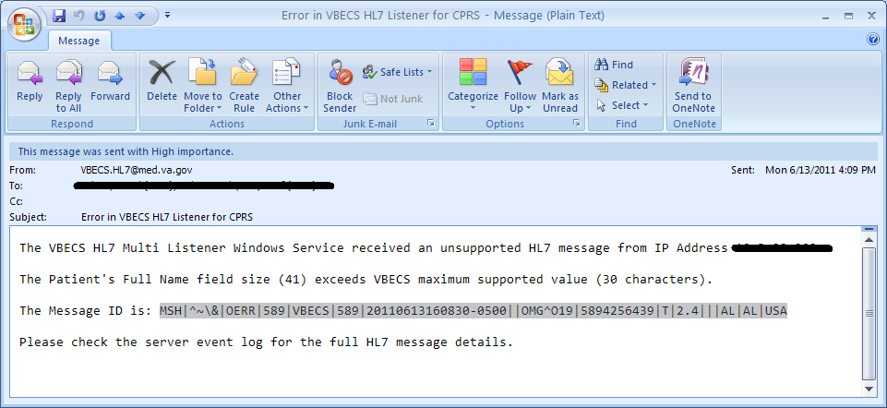

1. On the Application Server, click **Start, Administrative Tools, Event** **Viewer**.
2. On the Event Viewer Window, expand the **Windows Logs** and click on **Application** in the left-hand tree; click the top event in the log table, then click **Find** on the right side of the window(Figure 90).

Figure 90: Example of Event Viewer

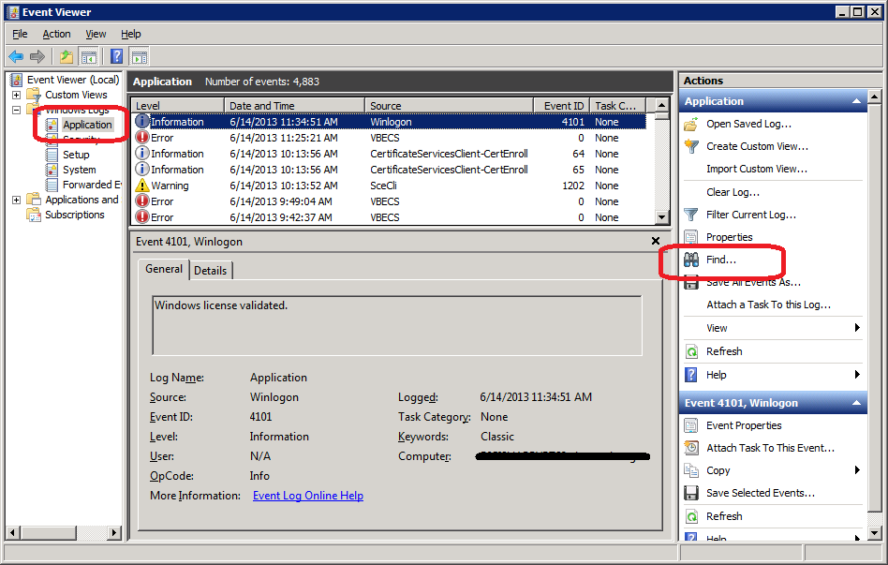

1. Paste the **MessageID** highlighted in the email received (Figure 89) in the **Find What** text box. Click **Find** **Next** (Figure 91).

Figure 91: Example of Find in Local Application



1. When the event record has been found, the row will be highlighted (Figure 92).

Figure 92: Example of Message ID Located in Event Log

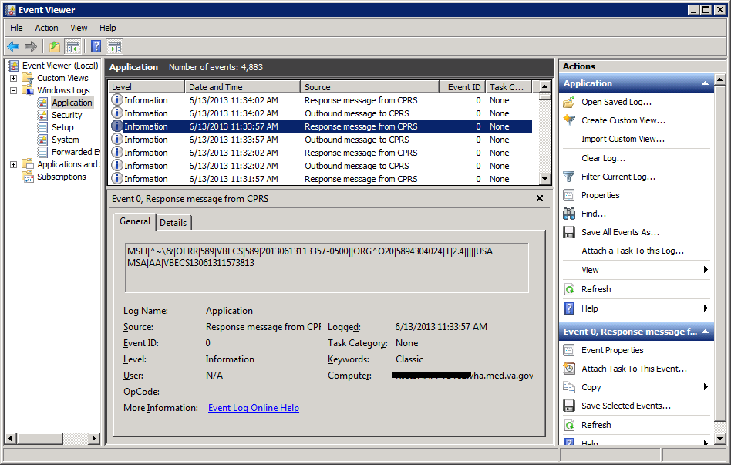

1. Click **Cancel** to close the Find window (Figure 91). The screen will now be display the found event.
2. Double-click on the highlighted row (Figure 93).

Figure 93: Example of Event Properties

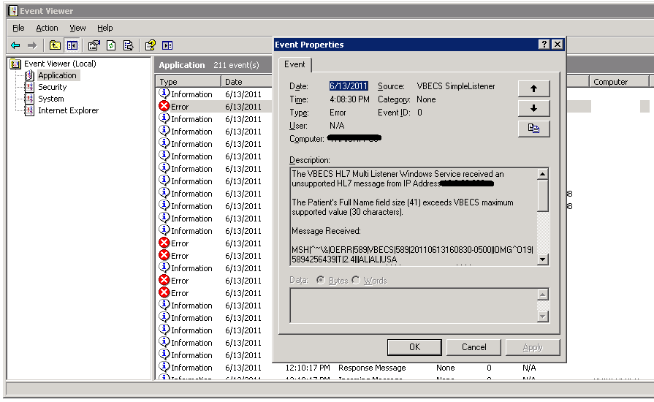

1. If the **Message ID** in the email is part of the Message Receive information in the Event Properties, analyze the detail message to identify the Patient Information causing the error (Figure 94).

Figure 94: Example of Analyzing Event Properties

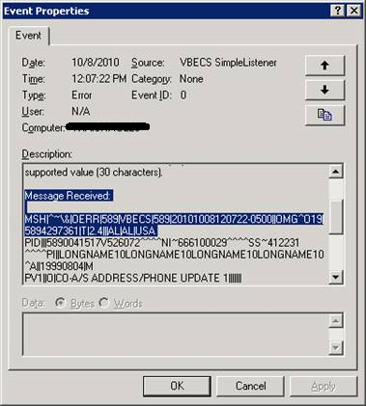

1. If the Message ID in the email is not found in the Message Received, proceed to the next error by repeating Steps 3 through 7.

### Zebra Printer Problems

### (DR 3722)

**Problem**: The printer prints, but there is no text on the label or text is too light.

**Probable Cause**: The printer is out of ribbon or the DARKNESS setting is too light (Figure 95).

**Solution**: Increase the DARKNESS setting after verifying printer has ribbon.

Figure 95: Example Zebra Printer Settings

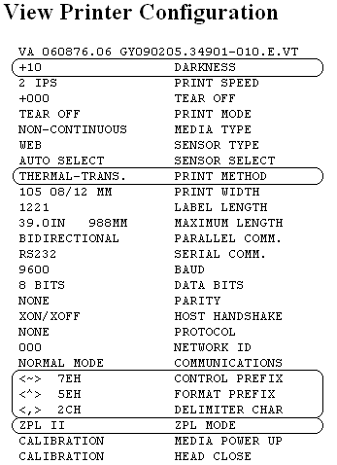

**Problem**: The printer does not print. It also cannot be pinged or be seen in a web browser (Figure 96).

**Probable Cause**: Network settings are not correct on the printer

**Solution**: Correct the printer’s network settings. All printer manuals may be found on the VBECS SharePoint.

Figure 96: Example of Zebra Printer Web Console

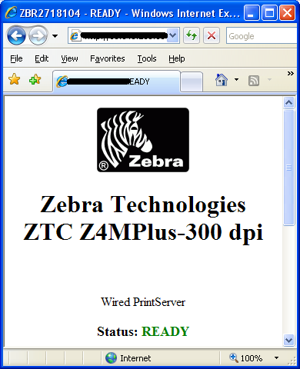

**Problem**: The printer does not print and network settings have been verified (see previous).

**Probable Cause**: One or more settings are incorrect.

**Solution**: Verify that the PRINT METHOD, CONTROL PREFIX, FORMAT PREFIX, DELIMITER CHAR and ZPL MODE match the settings in Figure 95.

**Problem**: The printer is online and network settings have been verified (see previous), but the printer fails to print.

**Probable Cause**: The network is blocking the printer, most likely due to a firewall. Test with Telnet PowerShell script. You may find it on **D:\VBECS-Tools\** (App Server) or **E:\VBECS-Tools\** (SQL Server) (Figure 97). Read the accompanying **readme** file for instructions.

**Solution**: Open the firewall to the printer on port 9100.

Figure 97: Example of Telnet test setup

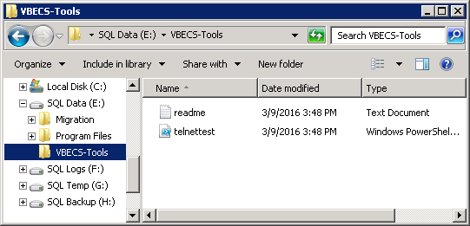

### Scanner Problems (DR3363)

**Problem**: When scanning, a **`** character appears at the start of the scan.

**Probable Cause**: The **Caps Lock** is on.

**Solution**: Turn the **Caps Lock** off.

**Problem**: When scanning, characters appear in the field that do not match the label being scanned. Often, the bad characters are not alphanumeric.

**Probable Causes**: Remote Desktop setting or network latency causes data to become corrupted.

**Solution #1**: First, try adjusting the keyboard settings in Remote Desktop Connection. Change the **Keyboard** setting to **On the local computer** (Figure 8). If this does not work, try solution #2.

**Solution #2**: The lab supervisor will program an inter-character delay into the scanner to fix the issue. This puts a small time-delay between each character as it is sent over the network, which results in slightly slower scan speeds.

Figure 98 through Figure 105 are configuration barcodes arranged from a 10-millisecond inter-character delay all the way up to an 80-millisecond delay respectively. We suggest that you start with the 10-millisecond delay. If that does not resolve the problem, proceed with larger delays until the problem is corrected.

Note that these barcodes include all of the configuration information for the scanners. There is no need to scan any additional barcodes to configure the scanner.

Figure 98: 10 milliseconds



Figure 99: 20 milliseconds



Figure 100: 30 milliseconds



Figure 101: 40 milliseconds



Figure 102: 50 milliseconds



Figure 103: 60 milliseconds



Figure 104: 70 milliseconds



Figure 105: 80 milliseconds



This page intentionally left blank.

### Archiving and Recovery (Enterprise Operations Only)

The VBECS database will be backed up once daily and the backup to tape can be taken any time after 1:00 AM (CST).

#### Assumptions

The SQL Server job that backs up the database is running correctly.

Replacement hardware will have a tape drive that is compatible with the one lost in the disaster.

#### Outcome

VBECS data is successfully recovered.

#### Limitations and Restrictions

None

#### Additional Information

None

### Restore the Databases

 If you find the need to perform a database restore and require assistance, file a support ticket (Service Desk Primary Contact) for the VBECS Maintenance Team.

#### Service Desk Primary Contact

For Information Technology (IT) support, call the Enterprise Service Desk (SD), 855-NSD-HELP (855-673-4357) toll free, 24 hours per day, 7 days per week.

#### Enterprise Service Desk Alternate Contacts

* Web site: [Service Desk Tuscaloosa](http://vaww.itsupportservices.va.gov/vasd_home.asp)
* Email: [vhacionhd@va.gov](mailto:vhacionhd@va.gov)

This page intentionally left blank.

# Failover

VBECS does not have a seamless failover mechanism. If an application server fails, the user will receive a message that the remote connection was lost. VBECS will lose information entered since the last save. The user must reopen a Remote Desktop Connection session. The user will have to reenter all information that was lost since the last save.

The connection between VBECS and VistA can be lost for a number of reasons:

An application server can fail or the VistA server can fail. When this connection is lost, no messages can be exchanged. When the connection between VBECS and VistA is lost due to a failure of VBECS, the messages are queued on the VistA side. Orders placed during this downtime will remain in the queue. Once the VBECS system recovers and a connection is reestablished with VistA, the messages come across. The order alerts icon located in the VBECS status bar will display the orders that were in the queue at the time of failure.

An application server can fail because of a vSphere failure. If the underlying physical host that VBECS resides on fails, the VBECS servers will fail too. vSphere clustering will restore the server on another host.

TechDoc Task 1082If a user’s client workstation fails in the middle of a VBECS session, the session remains active on the server for a period set by the server administrator. The standard session time-out is 15 minutes. If the user resolves the issues with the client workstation and reconnects to the VBECS server through Remote Desktop Connection before the session times out, the session will remain as it was when the client failed.

VBECS uses a feature within Microsoft SQL Server 2012 called AlwaysOn. SQL Server AlwaysOn provides both High Availability (HA) and Disaster Recovery for VBECS databases. HA is implemented within one datacenter through synchronous replication. If a primary SQL server should fail, the VBECS application is automatically directed to use the databases on the HA SQL server. This is a seamless failover and occurs automatically with no intervention needed. The previously defined HA server becomes the new primary server and when the original primary server recovers, it becomes the new HA server. This will occur during normal maintenance of the servers during Windows update deployment on a monthly basis as those servers are rebooted. Using the same AlwaysOn technology, disaster recovery is implemented through asynchronous replication between the primary data center and a disaster recovery data center. Unlike the HA configuration, activating a disaster recovery server requires manual intervention.

If the VBECS user is in the process of performing a query at the exact second a synchronous failover takes place, they are presented with the message shown in Figure 106:

Figure 106: Synchronous Failover Message

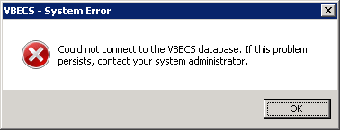

Once the VBECS user clicks OK, any open child dialogs automatically close to preserve data integrity. They may proceed to use VBECS and will not see this message again. This message could present itself in the event of a disaster recovery failover as well. In that case, the system will not recover automatically and the VBECS user continues to see this message every time they try to query the database. Manual failover recovery to the disaster recovery server takes place through written instructions defined in the Disaster Recovery Plan and requires the intervention and expertise of the datacenter and VBECS maintenance teams.

# Performance

VBECS may delay a critical function such as patient transfusion if the network suffers latency issues. File a support ticket (Service Desk Primary Contact) per local procedures when latency issues arise.

VBECS was re-factored after performance testing results showed latency issues for VistA queries. As a result, many queries are cached in the VBECS database. Due to the criticality of having correct and current patient data, patient lookups cannot be cached.

## Locking This is to address HA 12.16.

VBECS is designed with pessimistic locking controlled within the application code: if one user selects a record for edit, the record is locked by that user. If another user tries to edit that record, a message will tell him that the record is locked and who has the record. The second user is not granted access to the record.

Locks have a timeout period defined in the configure division portion of the VBECS Administrator application. When a lock times out or is released by a user completing his edit, another user can edit that record.

If the application code fails due to a logic bug, optimistic locking is in place to prevent data corruption. When a record is retrieved, a row version is also retrieved. When a record is saved, the row in the database gets an updated row version; before the save takes place, the save routine checks that the row version supplied matches the row version in the table. If it does not match, the routine notifies the caller that another user changed the data. The save does not complete; the user must retrieve the updated record and start his edits again.

If VBECS had an application error resulting in the application terminating, locks may have to be manually deleted. File a ticket (Service Desk Primary Contact).

This page intentionally left blank.

# Security

VBECS contains sensitive data and performs a critical function, so it is critical to secure the system. It is important to secure the server from both users and malicious attacks from an individual who is trying to gain access to the system.

## Access Request Process

To gain access to the VBECS server, follow the ePAS process (<https://vaww.sde.portal.va.gov/sites/eoservices/ISS/SAM/ePAS1/EO-EP%20Request%20Process.docx>).

 A NMEA must be used at all times to access a VBECS server with administrator access.

## Active Directory

Access to the VBECS servers is controlled through AD. Each VBECS site will have two groups set up in AD, one for normal VBECS users and one for VBECS Administrators (this is not a server administrator). Unless the user is a server administrator, he must be a member of one of these two groups to gain access to the server.

These groups also play a role in application level security. Even if a user were able to access the server, he would not be able to access VBECS.

## Group Policy

Group policy controls the user experience (what the user sees and has access to on the VBECS server). To configure this correctly, the recommendations in “*Windows Server 2008 R2 Security Guide*” (Microsoft Web site) were followed to establish a baseline for group policy.

Group policy can be applied to user accounts or to the servers directly. In the case of VBECS, group policy is applied to the servers (it is easier to manage). It is also undesirable to have group policy associated with the user, which may inhibit his use of other systems. Enabling loopback processing applies the policy to any user that logs into the server.

In some cases, group policy also enables VBECS to perform actions on the Windows operating system. For example, there is a group policy setting that allows the VBECS services to be restarted after a configuration change in VBECS Administrator.

## System Center Operations Manager

SCOM is a proactive monitoring tool. SCOM will constantly monitor each server for system abnormalities. If SCOM detects a problem, an email will be sent to the system administrator defined during the SCOM installation process. SCOM will monitor these high-level categories:

Windows Server 2008 R2 Operating System

CPU health and usage

Network interface cards

SQL Server (SQL Clustering and SQL AlwaysOn)

Memory usage

Hard-disk health and usage

VBECS files and services

Windows Services

## Application-Wide Exceptions TechDoc Task 813

Table 13 explains system exceptions to aid VA Health Product Support in determining the cause and resolving system issues.

Table 13: Application-Wide Exceptions

| **System Exceptions** | **Description** |
| --- | --- |
| [ArgumentException](http://msdn.microsoft.com/library/en-us/cpref/html/frlrfSystemArgumentExceptionClassTopic.asp) | Base class for all argument exceptions |
| [ArgumentNullException](http://msdn.microsoft.com/library/en-us/cpref/html/frlrfSystemArgumentNullExceptionClassTopic.asp) | Thrown by methods that do not allow an argument to be null |
| [ArgumentOutOfRangeException](http://msdn.microsoft.com/library/en-us/cpref/html/frlrfSystemArgumentOutOfRangeExceptionClassTopic.asp) | Thrown by methods that verify that arguments are in a given range |
| [ComException](http://msdn.microsoft.com/library/en-us/cpref/html/frlrfSystemRuntimeInteropServicesCOMExceptionClassTopic.asp) | Exception encapsulating COM HRESULT information |
| [Exception](http://msdn.microsoft.com/library/en-us/cpguide/html/cpcontheexceptionclass.asp) | Base class for all exceptions |
| [ExternalException](http://msdn.microsoft.com/library/en-us/cpref/html/frlrfSystemRuntimeInteropServicesExternalExceptionClassTopic.asp) | Base class for exceptions that occur or are targeted at environments outside the runtime |
| [IndexOutOfRangeException](http://msdn.microsoft.com/library/en-us/cpref/html/frlrfSystemIndexOutOfRangeExceptionClassTopic.asp) | Thrown by the runtime only when an array is indexed improperly |
| [InvalidOperationException](http://msdn.microsoft.com/library/en-us/cpref/html/frlrfSystemInvalidOperationExceptionClassTopic.asp) | Thrown by methods when in an invalid state |
| [NullReferenceException](http://msdn.microsoft.com/library/en-us/cpref/html/frlrfSystemNullReferenceExceptionClassTopic.asp) | Thrown by the runtime only when a null object is referenced. |
| [SEHException](http://msdn.microsoft.com/library/en-us/cpref/html/frlrfSystemRuntimeInteropServicesSEHExceptionClassTopic.asp) | Exception encapsulating Win32 structured exception handling information |
| System.ArithmeticException | A base class for exceptions that occur during arithmetic operations, such as System.DivideByZeroException and System.OverflowException |
| System.ArrayTypeMismatchException | Thrown when a store into an array fails because the actual type of the stored element is incompatible with the actual type of the array |
| System.DivideByZeroException | Thrown when an attempt to divide an integral value by zero occurs |
| System.IndexOutOfRangeException | Thrown when an attempt to index an array via an index that is less than zero or outside the bounds of the array |
| System.InvalidCastException | Thrown when an explicit conversion from a base type or interface to a derived type fails at run time |
| System.NullReferenceException | Thrown when a null reference is used in a way that causes the referenced object to be required |
| System.OutOfMemoryException | Thrown when an attempt to allocate memory (via new) fails |
| System.OverflowException | Thrown when an arithmetic operation in a checked context overflows |
| System.StackOverflowException | Thrown when the execution stack is exhausted by having too many pending method calls; typically indicative of very deep or unbounded recursion |
| System.TypeInitializationException | Thrown when a static constructor throws an exception, and no catch clauses exist to catch it |
| [SystemException](http://msdn.microsoft.com/library/en-us/cpref/html/frlrfSystemSystemExceptionClassTopic.asp) | Base class for all runtime-generated errors |

Table 14 explains the event sources that VBECS uses to write to the Application log in Event Viewer (Finding Application Log Entries from Email Alerts). DR 4881

Table 14: Event Sources

| **Event Source** | **Description** |
| --- | --- |
| VBECS Exception | A VBECS system crash |
| VBECS Prod | VBECS Production |
| VBECS Test | VBECS Test |
| VBECS Admin Prod | VBECS Administrator Production |
| VBECS Admin Test | VBECS Administrator Test |
| HL7Dispatcher Prod | VBECS Services |
| HL7Dispatcher Test |
| HL7Service Prod |
| HL7Service Test |
| ReportScheduler Prod |
| ReportScheduler Test |
| VistaLinkService Prod |
| VistaLinkService Test |

Figure 107: Event Sources

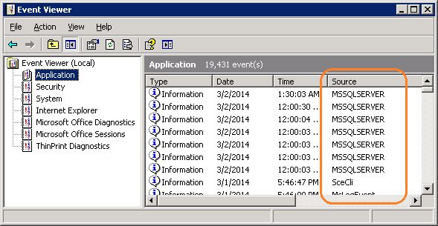

## Health Product Support Access

Health Product Support has full server administrative access to the App Server.

This page intentionally left blank.

Configuring the App Server and Lab Workstations

After the App Server is deployed, additional configuration will need to be performed on it and on the lab workstations. On the server, install the printer, configure permissions and create the Report share. On the workstation, create a shortcut to the report share.

## Server Tasks (Enterprise Operations Only)

Perform the following tasks on the App Server only.

### Grant User Permissions

1. Open a remote desktop connection to the VBECS App Server and login with server administrator privileges.
2. Click **Start**, **Administrative** **Tools**, **Computer** **Management**. Expand **Local Users and Groups**. Select **Groups** and double-click **Remote Desktop Users** (Figure 108).

Figure 108: Computer Management

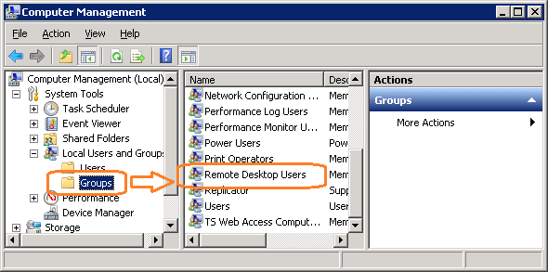

1. Click **Add** (Figure 109).

Figure 109: Remote Desktop Users Properties

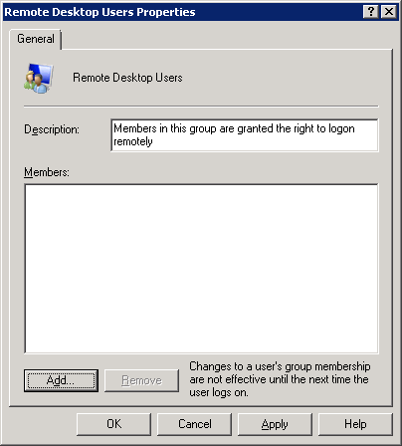

1. Specify the VBECS Users and VBECS Administrators group (Figure 110). Note that groups typically follow this naming convention (substitute the 3-letter site code for sss):
   * VBECS Users: *VHAsssVbecsUsers*
   * VBECS Administrators: *VHAsssVbecsAdministrators*

Click **OK** to close the window. Click **OK** again to close the **Properties** window.

Figure 110: Example of Select Users, Computers...

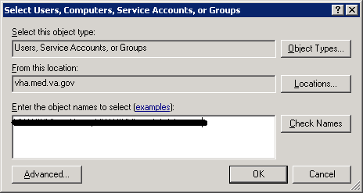

### Configure the Report Share

1. Open a remote desktop connection to the VBECS App Server and login with server administrator privileges.
2. Open Windows Explorer and navigate to the **D** drive.
3. Right-click on **VBECSReports** and click **Properties**. Select the **Security** tab and click **Edit** (Figure 111).

Figure 111: Example of VBECSReports Properties

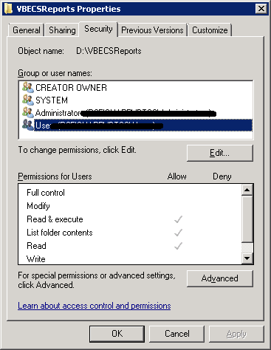

1. Click **Add** (Figure 112).

Figure 112: Example of Permissions

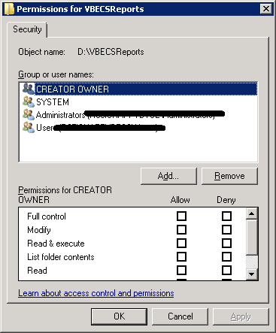

1. Specify the VBECS Users and VBECS Administrators group (Figure 113). Note that groups typically follow this naming convention (substitute the 3-letter site code for sss):
   * VBECS Users: *VHAsssVbecsUsers*
   * VBECS Administrators: *VHAsssVbecsAdministrators*

Click **OK** to close the window.

Figure 113: Example of Select Users, Computers...

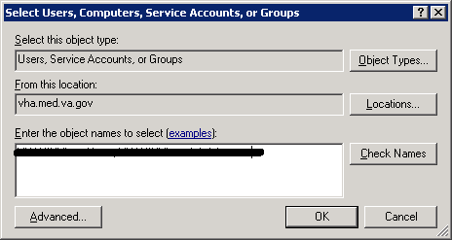

1. In the **Permissions** window, assign **Write** access to both groups in addition to the rights granted by default. Click **OK** (Figure 114).

Figure 114: Example of Permissions

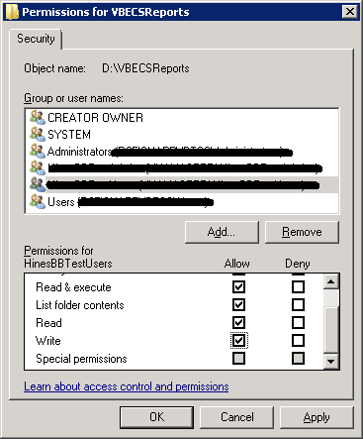

1. Select the **Sharing** tab and click **Advanced Sharing** (Figure 115).

Figure 115: VBECSReports Properties

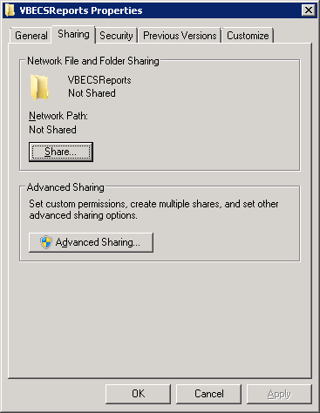

1. Click **Share this folder** and then **Permissions** (Figure 116).

Figure 116: Advanced Sharing

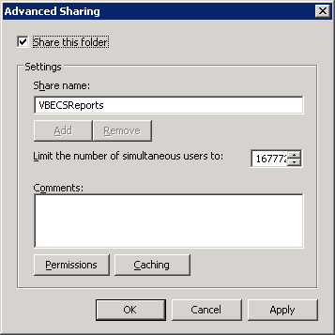

1. Click **Add** (Figure 117).

Figure 117: Permissions

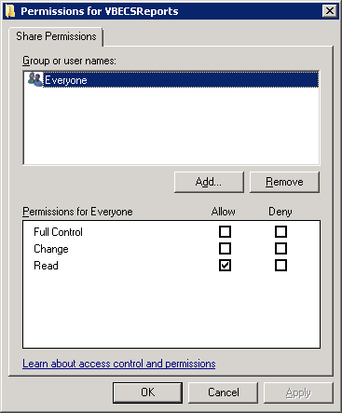

1. Specify the VBECS Users and VBECS Administrators group (Figure 118). Note that groups typically follow this naming convention (substitute the 3-letter site code for sss):
   * VBECS Users: *VHAsssVbecsUsers*
   * VBECS Administrators: *VHAsssVbecsAdministrators*

Click **OK**.

Figure 118: Example of Select Users...

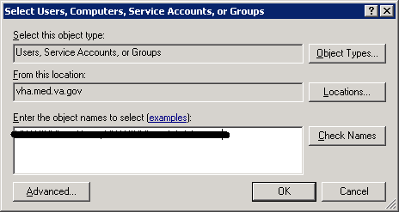

1. Select the VBECS Administrators group and select **Full Control**. Leave the default permissions for the VBECS Users group and click **OK** (Figure 119).

Figure 119: Permissions for VBECSReports

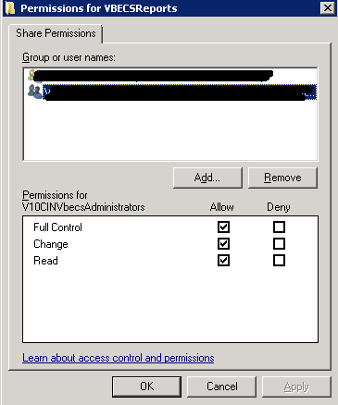

## Workstation Tasks

Update the RDP shortcut and create the report share on each lab workstation.

### Update the RDP Shortcut

1. Log into the lab workstation with administrator privileges.
2. Right-click on the VBECs remote desktop shortcut and click **Edit** (Figure 120).

Figure 120: Edit shortcut

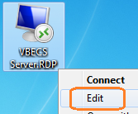

1. In the **Computer** field, the VBECS application server’s fully qualified domain name. The name will always be your server name followed by **aac.dva.va.gov** (Figure 121). Click **Save**.

Figure 121: Remote Desktop Connection



### Configure a Shortcut to the Report Share

The report share section (Configure the Report Share) must have been executed before proceeding with this section. The report share contains patient identifiable information, so the shortcut must only be accessible by authorized laboratory personnel. If the workstation will only be used by laboratory personnel, the shortcut may be placed in the **Public Desktop** folder. Otherwise, create it separately in each user’s folder.

1. Log into the lab workstation with administrator privileges. Navigate to the user’s desktop folder (C:\Users\Public\Public Desktop), right-click on the **Desktop** folder and select **New**, **Shortcut** (Figure 122). Note: If you cannot see the Public Desktop folder in the tree view type **C:\Users\Public\Public Desktop** in the address bar and hit enter.

Figure 122: Example of New Shortcut

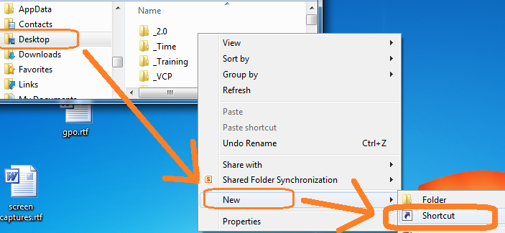

1. Enter the share name (**\\<VBECS application server fully qualified domain name >\VBECSReports**) and click **Next** (Figure 123).

Figure 123: Example of Report Share

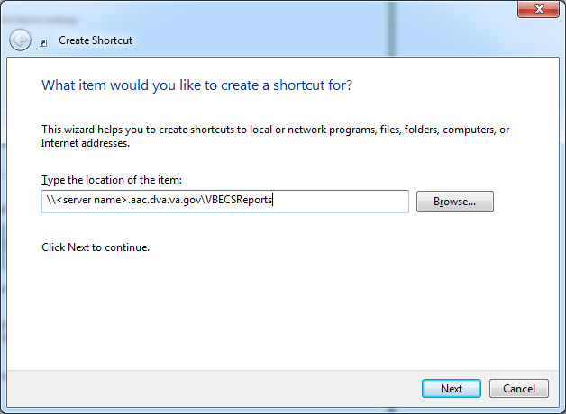

1. Name the shortcut **VBECSReports**. Click **Finish** (Figure 124).

Figure 124: Create Shortcut

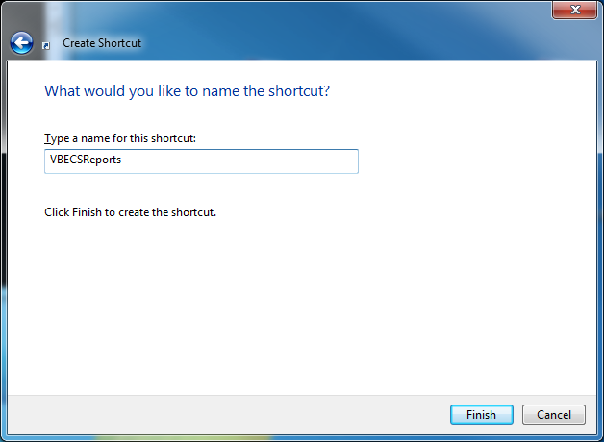

This page intentionally left blank.

# Glossary

| **Acronym, Term** | **Definition** |
| --- | --- |
| **ABO** | A group for classifying human blood, based on the presence or absence of specific antigens in the blood, which contains four blood types: A, B, AB, and O. The ABO group is the most critical of the human blood systems. It is used to determine general compatibility of donor units to a recipient. |
| **Access Code** | A field in the VistA New Person file used to uniquely identify a user on the VistA system. |
| **Active Directory (AD)** | A hierarchical directory service built on the Internet's Domain Naming System (DNS). |
| **ADPAC** | Automated Data Processing Application Coordinator. |
| **AG** | Availability Group. |
| **ANR** | Automated Notification Report. |
| **API** | Application Programmer Interface. |
| **AITC** | Austin Information Technology Center. |
| **BCE** | Bar Code Expansion. |
| **CPRS** | Computerized Patient Record System. |
| **DBIA** | Database Integration Agreement. |
| **DR** | Disaster Recovery. |
| **DSS** | Decision Support System. |
| **DUZ** | Designated User. |
| **EO** | Enterprise Operations. |
| **FQDN** | Fully Qualified Domain Name. |
| **HA** | High Availability. |
| **HCPCS** | Healthcare Common Procedure Coding System. |
| **HL7** | Health Level Seven. |
| **LAN** | Local Area Network. |
| **LLP** | Lower Layer Protocol. |
| **LMIP** | Laboratory Management Index Program. |
| **PCE** | Patient Care Encounter. |
| **PIV** | Personal Identification Verification. |
| **RDP** | Remote Desktop Protocol. |
| **RPC** | Remote Procedure Call. |
| **SQL** | Structured Query Language. |
| **SSMS** | SQL Server Management Studio. |
| **SCOM** | System Center Operations Manager. |
| **TCP/IP** | Transmission Control Protocol/Internet Protocol. |
| **VAISS** | VBECS Application Interfacing Support Software. |
| **VBECS** | VistA Blood Establishment Computer Software. |
| **VDL** | VA Software Document Library. |
| **Verify Code** | A field in the VistA New Person file used to verify the identity of a user associated with an Access Code. |
| **VISN** | Veterans Integrated Service Network. |
| **XML** | Extensible Markup Language. |

# Appendices

## Appendix A: Instructions for Capturing Screen Shots

Throughout the technical manual-security guide, the Administrator is asked to capture screen shots to document configuration options. To capture a screen shot:

* Open a blank document (for example, in Microsoft Word) and save it as (click **File**, **Save As**) “mmddyy Technical-Security Validation Record,” or another easily identified file name.

 If you wish to place a document on the server for ease of copying and pasting, assign file names similar to “mmyydd Technical-Security Validation Record Server1” and “mmyydd Technical-Security Validation Record Server2.”

When the screen you wish to capture is displayed, press the **Print Screen** key.

In the Technical-Security Validation Record document, place the cursor where you want to insert the picture.

Click  (the paste icon) or select **Edit**, **Paste (**Figure 125**)**.

Figure 125: Paste

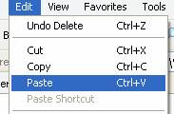

Label the screen shot within the document with the technical manual-security guide step, page number, and server on which the picture was taken.

This page intentionally left blank.

## Appendix B: Data Center Instructions (Enterprise Operations only)

### Purpose

This appendix describes the server configuration as well as the tasks that must be completed by the data center for a successful VBECS installation:

* Initial Setup Tasks: These tasks must be completed prior to installation of any VBECS systems.
* Ongoing Tasks: These are continual maintenance tasks.

### Server Configuration

 The U.S. Food and Drug Administration classifies this software as a medical device. Unauthorized modifications will render this device an adulterated medical device under Section 501 of the Medical Device Amendments to the Federal Food, Drug, and Cosmetic Act. Acquiring and implementing this software through the Freedom of Information Act require the implementer to assume total responsibility for the software and become a registered manufacturer of a medical device, subject to FDA regulations.

 VBECS is a medical device; all updates and changes to it must be tested and documented. This will be centrally managed. The VBECS servers must be added to site exclusion lists so they are not part of local update mechanisms. Ensure that login scripts do not run on VBECS servers as they may attempt to install unauthorized software. Do not install the ePolicy agent on the VBECS systems: exclude them from Systems Management Server (SMS) updates. Install Windows updates only after approval is granted.

#### App and Database Server Virtual Machine Configurations

Table 15 and Table 16 describe the configurations of the App and Database Server virtual machines respectively.

These configurations are designed to promote 24/7 availability and use of the application. At an App Server level, replication provides high availability. At the Database Server level, AlwaysOn cluster configuration provides near immediate failover in case the primary server fails.

Table 15: App Server Virtual Machine Configuration

|  |  |
| --- | --- |
| **App Server Specifications** | |
| Processor | 2 virtual CPUs (vCPUs) with a speed of 2.67GHz |
| Memory | 6 gigabyte (GB) main storage (RAM) |
| Storage | 80GB system drive (C) with a 10GB (D) drive to host configuration and reports |
| Operating System | Microsoft Windows Server 2008 Server Enterprise Edition R2 (x64) |
| Network Controller | Two 10/100 network cards; one for network configuration and another for backups. |
| Backup | Servers are replicated at the disaster recovery site. |

Table 16: Database Server Virtual Machine Configuration

|  |  |
| --- | --- |
| **Database Server Specifications** | |
| Processor | 4 vCPUs: Xeon(R) X5650 @ 2.67GHz |
| Memory | 32GB main storage (RAM) |
| Storage | **Server**: 80GB system drive (C)  **Shared storage**: 4 x 980GB drives*: E (Data), F (Logs), G (TempDB) and H (Backup) |
| Operating System | Microsoft Windows Server 2008 Server Enterprise Edition R2 (x64) |
| Network Controller | Two 10/100 network cards; one for network configuration and another for backups. |
| Backup | Data is replicated to the disaster recovery site via SQL AlwaysOn. |

*The drives used in the test servers will be scaled down.

#### Physical Host Configurations

Table 17 describes the requirements of the hosting hardware. Input/Output Operations per Second (IOPS) is a storage benchmark. The Storage Totals row describes the total amount of storage that each region must provide.

Table 17: App Server Virtual Machine Configuration

|  |  |  |  |  |  |
| --- | --- | --- | --- | --- | --- |
| **Specification** | | **R01** | **R02** | **R03** | **R04** |
| IOPS | Read (Avg/ Max) | 654/ 5,265  2,435/ 10,435 | 658/ 5,326  2,445/ 10,543 | 985/ 7,959  3,663/ 15,761 | 646/ 5,143  2,418/ 10,220 |
| Write (Avg/ Max) |
| Storage Totals | | 31.16 TB | 31.32 TB | 46.9 TB | 30.84 TB |

### Initial Setup Tasks

Execute the tasks in this section prior to installation.

#### Group Policy

For Group Policy purposes, VBECS servers will reside in their own OU, which will contain only VBECS servers. You may also create OUs under the main OU for organizational purposes. For more information, see the Group Policy section.

Import the *VHA VBECS Terminal Server Policy* from the VHAMASTER domain. Place the group policy in the top-level server OU. For more information about OUs and server organization, see the Active Directory section.

Configure the policy so that it is not applied to the R*xx*VbecsServerAdmins Active Directory group. See the example in Figure 126.

Figure 126: Example of a Group Policy Not Applied to VBECSAdministrators Group

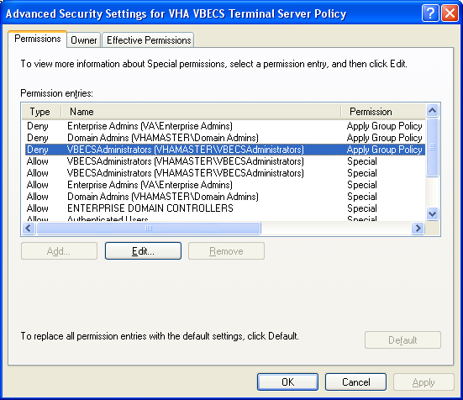

#### RDP Server

VBECS is a RDP Server application and requires a license. Specify the license server in the group policy at the following location:

* Computer Configuration, Policies, Administrative Templates, Windows Components, Remote Desktop Services, Remote Desktop Session Host, Licensing, Use the specified Remote Desktop license servers (**Enabled**), License servers to use: **<specify the VA’s license server with the server’s fully qualified domain name>**

 Remote desktop is critical to VBECS. Failure to connect to a license server will result in widespread outages. If you see errors related to Terminal Server licensing, contact the Enterprise Engineering group immediately:VAITEngineeringCISIDM@va.gov.

### Ongoing Tasks

Execute the tasks in this section continually.

#### Back Up the VBECS Database

Back up the VBECS databases nightly (1am CST):

* + Back up all folders and files in the <Primary Server> H:\Program Files\Microsoft SQL Server\MSSQL11.MSSQLSERVER\MSSQL\Backup  and <Secondary (HA) Server> H:\Program Files\Microsoft SQL Server\MSSQL11.MSSQLSERVER\MSSQL\Backup  directories.
  + Database backups are maintained for at least seven days on the Primary and Secondary (HA) servers.

#### VBECS Updates

When the VBECS maintenance team releases a VBECS patch, install the patch in accordance with instructions supplied by the VBECS maintenance team.

#### Windows Updates

The VBECS maintenance team tests every Microsoft Windows update. Once the VBECS maintenance team certifies the Microsoft Windows update, EO staff at the AITC install the updates during the monthly maintenance periods defined for the test and production servers. Refer to *Applying Windows Updates* section for details.

## Appendix C: Auditing on VBECS Servers (3512)

The following events are audited on VBECS servers. These events may be viewed in Event Viewer logs (under Administrative Tools):

* Account logon events (Success, Failure)
* Account management (Success, Failure)
* Directory service access (Success, Failure)
* Logon events (Success, Failure)
* Object access (Success, Failure)
* Policy Change (Success, Failure)
* System events (Success, Failure)

This page intentionally left blank.

# Index

A

Active Directory 119

Appendices 137

Application-Wide Exceptions 120

Archiving and Recovery 113

B

Back Up the VBECS Database 142

C

Commonly Used System Rules 5

Configure Auto Instrument Interface Parameters 71

Configure BCE COTS Interface Parameters 68

Configuring the App Server and Lab Workstations for VBECS 2.2.1 123

Connection Speed 12

Create a Remote Desktop Connection Shortcut for VBECS 14

D

Data Center Instructions 139

Database Conversion Updates 143

E

ePolicy and Virus Definitions 44

External Interfaces 89

F

Failover 115

G

Glossary 135

Group Policy 119, 140

H

Hardware and System Configuration 15

Hardware Specifications and Settings 7

Health Product Support Access 121

How This Technical Manual-Security Guide Is Organized 5

I

Implementation and Maintenance 27

Instructions for Capturing Screen Shots 137

Introduction 1

L

Locking 117

M

Maintenance Operations 51

Monitor VBECS HL7 Logical Links 48, 50

O

Ongoing Tasks 140, 142

P

Performance 117

Printers 17

Purpose 139

R

Related Manuals and Reference Materials 3

Remote Desktop Configuration 7

S

Save Settings 13

Scanners 24

Screen Resolution 7

Screen Shots 5

Security 119

Server Configuration 139

Set Up the VBECS Inbound Logical Link 47

Set Up VBECS Outbound Logical Links 45

Sound 10

Start VistA HL7 Logical Links 48

System Center Operations Manager 119

T

Terminal Server License Server 141

Transmit Workload Data 87

V

VBECS Updates 142

VBECS Windows Services 90

VistALink Remote Procedure Calls 89

W

Windows Updates 142

# 

This is the last page of the *VistA Blood Establishment Computer Software (VBECS) 2.2.1 Technical Manual-Security Guide*.

1. There is a slight difference in terminology between VistA and VBECS: VistA uses “log on” and “logon,” and VBECS uses “log in” and “login.” Therefore, both terms are used throughout this manual. “Log in” and “login” are used generically when referring to both systems at one time.